**A PROJECT REPORT**

**ON**

**“Virtual Painter Using Computer Vision**”

**SATYABRATA SAHOABSTRACT**

We present a real-time on-device hand tracking solution that predicts a hand skeleton of a human from a single RGB camera for AR/VR applications. Our pipeline consists of two models: 1) a palm detector, that is providing a bounding box of a hand to, 2) a hand landmark model, that is predicting the hand skeleton. It is implemented via MediaPipe[12], a framework for building cross-platform ML solutions. The proposed model and pipeline architecture demonstrate real-time inference speed on mobile GPUs with high prediction quality. MediaPipe Hands is open sourced at <https://mediapipe.dev> .

**CHAPTER-1**

**Introducing to Python**

So, you want to learn programming. Welcome to one of the great adventures of the twenty-first century. Programming requires little in the way of specialized equipment; the software tools can all be downloaded for free off the Internet, and it can be practiced in the safety and comfort of your own home, without having to ask anyone’s permission. This chapter will ease you in gently by introducing you to the software you will need to create your programs: a command-line interface, which allows you to use Python in interactive mode, and a text editor for writing scripts—nothing more complicated than that. I will also show you where to go to find help and documentation, so you can decode the sometimes-impenetrable jargon that seems to surround this, the geekiest of all technical disciplines. To begin with, you will need to make sure that you have a decently recent version of Python installed on your machine or follow the steps later in this chapter to install it (see “Choosing the Right Python Version” for a definition of decently recent). This chapter explains how to make sure that you have everything set up correctly and that you have suitable references at hand before you start your journey. Python is an excellent language with which to learn programming. There are many reasons for this, but the simple explanation is that it’s easy to read and fast to write; it doesn’t take long to come up with working code that does something meaningful. Python has a very human-friendly syntax, which makes writing elegant code easy. The basic language is fairly simple and therefore easy to remember, and then it has an extensive library of predefined functions that you can use to facilitate most common computer tasks. Writing effective applications in Python can be as simple as playing with conceptual building blocks. It works really well for writing a little two-line application to perform some routine system administration tasks or to provide interactive functions on a web page, but it has enough power and flexibility to comfortably create much larger and more complex applications with graphic interfaces indistinguishable from the programs you are used to running from your computer’s main menu. If you follow the suggestions laid out in this book about writing self-explanatory code, in several months, even years, you will be able to come back to your programs and see immediately what they were supposed to do and what your original intentions were; this makes maintaining programs much simpler too. OK, let’s make sure your system is ready for you to start running Python programs.

**Running Python on Various Systems**

Python can be installed and run on most operating systems including Windows, Mac OS X, or OS/2, Linux, and Unix. If you are running Mac OS X or a GNU/Linux system, you will probably have it installed by default. I would recommend using a system of this kind, which already has Python set up as an integral part. The book was written using a Debian GNU/Linux system, and therefore, the examples will work exactly the same on any Debian-based system, such as Ubuntu. In fact, the differences between Linux variants are few, so you’ll be equally at home with other distributions.

**Installing on Windows**

If you are using Windows, you will probably have to install Python and configure certain settings correctly before you can get to grips with the examples in this book. For that, you will need to refer to the specific instructions for your operating system on the following Python web pages:

• http://wiki.python.org/moin/BeginnersGuide/Download

• http://www.python.org/doc/faq/windows/

• http://docs.python.org/dev/3.0/using/windows.html

First, you need to download the official installer; alternative versions for Itanium and AMD machines are available from http://www.python.org/download/. You should save this file, which will have a .msi extension, somewhere you’ll be able to find again easily. You can then double-click this file to start the Python installation wizard, which will take you through the installation. It’s fine to accept the default settings if you’re not sure of any answer.

**Installing on Other Systems**

You may choose to install Python on other systems, particularly if you want to take advantage of newer versions. For Linux and other Unix-like systems, the installation instructions are here:

• <http://docs.python.org/dev/3.0/using/unix.html>

If you’re using OS X, your instructions are here:

• <http://www.python.org/download/mac/>

• <http://docs.python.org/dev/3.0/using/mac.html>

**Choosing the Right Python Version**

You will find the different installers include a number after the word Python. This is the version number. When I started writing this book, those numbers ranged from 2.3.7 (old but still usable) through 2.5.2 (the previous stable version) to 3.0 (the new version about to be released). At the same time as version 3.0 was released, the Python team also put out version 2.6, which is an upgraded version of Python version 2 for people who want (or need) to stick with the old way of doing things but still want to benefit from general fixes and some of the new features introduced in version 3.0. The Python language is continuously evolving; version 3.0 has become the norm and has evolved into version 3.1.1. The new version, which I’ll refer to as version 3.0 because all 3.x versions are simply refinements on the original plan of 3.0, includes several changes to the programming language that are incompatible with version 2.x (x is any number you like), which I will refer to in the rest of this book as the old version. Most of the language is the same, however, so the differences between the versions of Python will be noted in the text as those subjects are covered. Examples in this book are for Python 3.0 except where noted.

Further information about the latest version of Python 3.0 (also known as Py3k or Python 3000) is available at http://www.python.org/download/releases/.

There may be some differences running Python on other operating systems, which I will do my best to point out where relevant. Otherwise, the examples of code will work the same way. This is one of the many good points of Python. For the most part, this book will concentrate on the fun part learning how to write programs using Python. The official Python documentation is plentiful, free, and well written, and you should read it alongside this book. It is available on at <http://www.python.org/doc/>.

**Below are some facts about Python Programming Language:**

1. Python is currently the most widely used multi-purpose, high-level programming language.
2. Python allows programming in Object-Oriented and Procedural paradigms.
3. Python programs generally are smaller than other programming languages like Java. Programmers have to type relatively less and indentation requirement of the language, makes them readable all the time.
4. Python language is being used by almost all tech-giant companies like – Google, Amazon, Facebook, Instagram, Dropbox, Uber… etc.
5. The biggest strength of Python is huge collection of standard libraries which can be used for the following:

* Machine Learning
* GUI Applications (like Kivy, Tkinter, PyQt etc. )
* Web frameworks like Django (used by YouTube, Instagram, Dropbox)
* Image processing (like OpenCV, Pillow)
* Web scraping (like Scrapy, Beautiful Soup, Selenium)
* Test frameworks
* Multimedia
* Scientific computing
* Text processing and many more.

**What is Python?**

Python is a high-level scripting language which can be used for a wide variety of text processing, system administration and internet-related tasks. Unlike many similar languages, its core language is very small and easy to master, while allowing the addition of modules to perform a virtually limitless variety of tasks. Python is a true object-oriented language, and is available on a wide variety of platforms. There’s even a python interpreter written entirely in Java, further enhancing python’s position as an excellent solution for internet-based problems.

Python was developed in the early 1990’s by Guido van Rossum, then at CWI in Amsterdam, and currently at CNRI in Virginia. In some ways, python grew out of a project to design a computer language which would be easy for beginners to learn, yet would be powerful enough for even advanced users. This heritage is reflected in python’s small, clean syntax and the thoroughness of the implementation of ideas like object-oriented programming, without eliminating the ability to program in a more traditional style. So, python is an excellent choice as a first programming language without sacrificing the power and advanced capabilities that users will eventually need.

Although pictures of snakes often appear on python books and websites, the name is derived from Guido van Rossum’s favourite TV show, “Monty Python’s Flying Circus”. For this reason, lots of online and print documentation for the language has a light and humorous touch. Interestingly, many experienced programmers report that python has brought back a lot of the fun they used to have programming, so van Rossum’s inspiration may be well expressed in the language itself.

**The very Basics of Python**

There are a few features of python which are different than other programming languages, and which should be mentioned early on so that subsequent examples don’t seem confusing. Further information on all of these features will be provided later, when the topics are covered in depth.

Python statements do not need to end with a special character – the python interpreter knows that you are done with an individual statement by the presence of a newline, which will be generated when you press the “Return” key of your keyboard. If a statement spans more than one line, the safest course of action is to use a backslash (\) at the end of the line to let

python know that you are going to continue the statement on the next line; you can continue using backslashes on additional continuation lines. (There are situations where the backslashes are not needed which will be discussed later.)

Python provides you with a certain level of freedom when composing a program, but there are some rules which must always be obeyed. One of these rules, which some people find very surprising, is that python uses indentation (that is, the amount of white space before the statement itself) to indicate the presence of loops, instead of using delimiters like curly braces ({}) or keywords (like “begin” and “end”) as in many other languages. The amount of indentation you use is not important, but it must be consistent within a given depth of a loop, and statements which are not indented must begin in the first column. Most python programmers prefer to use an editor like emacs, which automatically provides consistent indentation; you will probably find it easier to maintain your programs if you use consistent indentation in every loop, at all depths, and an intelligent editor is very useful in achieving this.

**Why Choose Python?**

If you’re going to write programs, there are literally dozens of commonly used languages to choose from. Why chooses Python? Here are some of the features that make Python an appealing choice.

**Python is Popular**

Python has been growing in popularity over the last few years. The 2018 Stack Overflow Developer Survey ranked Python as the 7th most popular and the number one most wanted technology of the year. World-class software development companies around the globe use Python every single day.

According to research by Dice Python is also one of the hottest skills to have and the most popular programming language in the world based on the Popularity of Programming Language Index.

Due to the popularity and widespread use of Python as a programming language, Python developers are sought after and paid well. If you’d like to dig deeper into Python salary statistics and job opportunities, you can do so here.

**Python is Interpreted**

Many languages are compiled, meaning the source code you create needs to be translated into machine code, the language of your computer’s processor, before it can be run. Programs written in an interpreted language are passed straight to an interpreter that runs them directly.

This makes for a quicker development cycle because you just type in your code and run it, without the intermediate compilation step.

One potential downside to interpreted languages is execution speed. Programs that are compiled into the native language of the computer processor tend to run more quickly than interpreted programs. For some applications that are particularly computationally intensive, like graphics processing or intense number crunching, this can be limiting.

In practice, however, for most programs, the difference in execution speed is measured in milliseconds, or seconds at most, and not appreciably noticeable to a human user. The expediency of coding in an interpreted language is typically worth it for most applications.

**Python is Free**

The Python interpreter is developed under an OSI-approved open-source license, making it free to install, use, and distribute, even for commercial purposes.

A version of the interpreter is available for virtually any platform there is, including all flavours of Unix, Windows, macOS, smartphones and tablets, and probably anything else you ever heard of. A version even exists for the half dozen people remaining who use OS/2.

**Python is Portable**

Because Python code is interpreted and not compiled into native machine instructions, code written for one platform will work on any other platform that has the Python interpreter installed. (This is true of any interpreted language, not just Python.)

**Python is Simple**

As programming languages go, Python is relatively uncluttered, and the developers have deliberately kept it that way.

A rough estimate of the complexity of a language can be gleaned from the number of keywords or reserved words in the language. These are words that are reserved for special meaning by the compiler or interpreter because they designate specific built-in functionality of the language.

Python 3 has 33 keywords, and Python 2 has 31. By contrast, C++ has 62, Java has 53, and Visual Basic has more than 120, though these latter examples probably vary somewhat by implementation or dialect.

Python code has a simple and clean structure that is easy to learn and easy to read. In fact, as you will see, the language definition enforces code structure that is easy to read.

**But It’s Not That Simple**

For all its syntactical simplicity, Python supports most constructs that would be expected in a very high-level language, including complex dynamic data types, structured and functional programming, and object-oriented programming.

Additionally, a very extensive library of classes and functions is available that provides capability well beyond what is built into the language, such as database manipulation or GUI programming.

Python accomplishes what many programming languages don’t: the language itself is simply designed, but it is very versatile in terms of what you can accomplish with it.

**Learning While Having Fun**

Having fun is often underestimated in the realm of technical disciplines. We learn best and are most productive when we’re having fun. Developing software using Python is often an engrossing and enjoyable experience, partly because you can test out your changes as soon as you have made them without having to perform any intermediary steps.

Python also deals with many background tasks, the household chores of programming, so you don’t have to bother with them as you might in languages like C. This kind of immediate gratification makes it easier to stay in the creative flow and keep being inspired.

Python is also easy to read, being closer to natural language than many other programming languages, so you spend less time trying to decode what you have just written, which in turn means more time to think about how you could improve and expand your work.

The other great thing is that you can use Python for pretty much any task you can think of, be it large or small, simple text-driven script or major graphical application. It does have its limitations, but by the time you come up against them, you will already have become a competent programmer and will be able to make an informed choice about where to go next.

**Choosing to Code with a Text Editor**

My preferred method of creating Python scripts is to use a plain text editor, with a few basic programming features. Programs like notepad (especially notepad2/++), BBedit, gedit, NEdit and Kate are ideal for this task. A variety of editors are available that offer specific enhancements for programmers, such as syntax highlighting, which is useful for showing coding errors immediately as you type. Old-school hackers may prefer to use Vi or Emacs. Python does not dictate what software you use to create the code; the choice is up to you. Do not attempt to use word-processing software, such as Word or OpenOffice for this task; it will mess you up badly. Be warned!

**Choosing to Code with an Integrated Development Environment**

An integrated development environment (IDE) is a graphical interface with lots of useful features designed to make programming with Python even easier. You still have to type the code in the same way, but you can do all your coding using a single application, and these programming environments can provide some useful shortcuts and reminders. There are now several Python-specific IDEs. Popular applications include IDLE (which is bundled with Python itself), Eric (you may notice a theme here, nudge nudge, wink, say no more...), Geaney, Dr. Python, and SPE. Python is also supported by more general programming environments like Bluefish and a whole host of others. This book doesn’t cover the use of IDEs or any of the alternative distributions of Python, because each of these approaches would require a chapter unto themselves, at the very least. However, the examples contained in this book will still work if you do choose to explore these options. This book will take the simplest approach, using tools that come as standard with most operating systems; that is, a text editor and the Python Interactive Shell.

**Getting Started with Programming**

The process of writing a new program usually starts with a problem. Before you can code anything, you need to have an idea of what you want to create, the problem you wish to solve, and a fairly good idea of how to solve it. Chapter 2 will take you through the process of designing software, known as the software development cycle. Usually, this is something that you have to learn separately, as most programming manuals go straight into the details of the language, assuming you will have studied program design at college or in the process of learning some other programming language. This can lead you to create code that is difficult to read and understand and makes fixing problems later a nightmare. Understanding the principles of software design can dramatically speed up the process of creating new software and help ensure that important details are not missed out.

In Chapter 3, you start coding those designs in Python. You will learn about constructing the basic units of data, words and numbers, and how to combine and manipulate them. In Chapter 4, I will show you how to compare values, make choices, and deal with errors. The subsequent chapters go through the process of refining those designs, breaking them down into manageable chunks, and expanding your understanding of the Python programming language so you can turn your ideas into fully fledged, functional computer programs.

**CHAPTER -2**

If you are anything like me, you impatiently started reading this book at Chapter 3, became really confused about halfway through, and decided to start at the beginning and read it all properly this time. This chapter explains the bit that most manuals leave out: how to actually turn your problem into a working program. The first stage of the software development cycle is the creation of a program design. In this chapter, I’ll demonstrate how to break down your ideas into manageable chunks, understand each problem that you are trying to solve, build up a sequence of actions, keep track of what you’ve done, and above all, how to go about the constant refinement and simplification of your ideas that will lead to an effective solution that is easy to understand. I’ll be introducing you to pseudocode, the software design language, and showing you how to turn it into Python documentation strings to create a framework around which you can grow an effective and maintainable piece of software.

Your first challenge, which I’ll be using as an example for this chapter, is to get the computer to respond to a command and print out some kind of response—fairly basic stuff, which you could probably guess at a solution for. However, it’s always good to start as we mean to go on, so I’m going to break this down in terms of the software development cycle. In order to get off the starting blocks, it is necessary to identify the problem through a process of asking the right questions and then begin developing a solution, initially by creating a wish list of the things you want your new program to do and getting feedback from potential users. You will use all this information to create your initial program design.

In the next part of this chapter, you will be able to start turning that design into working code. As soon as the design is coded, you will want to begin refining and testing it, starting with defining the results you expect to get and then figuring out how to detect and correct errors.

In the final stage of the software development cycle, you will discover how to use docstrings to document the solution and see how this then feeds back into the next round of the development cycle.

**Designing Your Own Software (Why Bother?)**

There are many reasons that you might want to write your own software, the chief one being that the applications you have available don’t do what you want in the way that you want. You may already have an idea of something you wish to achieve, which led you to pick up this book in the first place. Perhaps you need a solution for work; maybe you have a killer game idea that you’d like to realize; you might want to organize some data in a web page or perform some system administration tasks. You might want to control a gadget you just built or automate any number of repetitive jobs. Possibly, you already have the program you need, if only it would do this one extra thing, or maybe you just enjoy the idea that writing your own software is possible. I’m not going to try to tell you why you should want to get involved in this peculiar sport; I’ll assume you have worked that out for yourself already.

Let’s start by asking some questions. Never be afraid to ask questions. Why bother doing all this? Why not just go straight ahead and start writing code? Coming up with a clear design first, along with a clear idea of what answers you expect to see, cuts down on a lot of wasted effort and makes your programs easier to document, troubleshoot, and maintain. It is important to remember that you are trying to make life easier—not more complicated—for yourself and others.

**Asking the Right Questions**

“Why bother?” is an important programming question that should be applied to every project, module, function, or line of code before you begin. There is a strong possibility that someone, somewhere has already written the software you need, or at least something very similar, that you could convert to your needs with the addition of a couple of lines of code.

Close on its heels comes the next question, “Isn’t there a simpler way to do this?” Laziness is the programmers’ ally; you probably won’t have to write very much from scratch, and you won’t need to learn everything by heart before you begin. Generally speaking, you can look up most things as you go along. The art of programming has much more to do with figuring out a logical procedure to get something done than memorizing lines of code; indeed, one of the most common practices involved in coding is simplification. Your first task is about as simple as it gets, but as the book progresses, you will be facing much more complex problems as well as coming up with ideas of your own.

**Using Python to Solve Problems**

Python is similar in style to pseudocode, the language programmers use to design software, with the difference that you can run it on your computer and actually get results. It’s easy to read (being close to English), fun to learn, and doesn’t require compiling, that is, you can run your script as soon as you have saved it without having to perform any intermediate steps. Python is also a useful language in that it can be used to deal with a wide range of problems with relative ease, and it has a good selection of preconstructed modules to deal with many of the more common computer tasks. I find it similar to playing with conceptual building blocks: the elements of the language are fairly simple to grasp, but they can be combined in pretty much any way you can think of to create apparently complex and graceful structures.

One of the other great features of Python is that it is self-documenting. You still have to write the documentation yourself, but you can include blocks of help text, known as documentation strings or docstrings, within the structure of the program itself. I will be using this particular feature to keep all the design ideas together in one file at the outset and allow us to think on paper. Subsequently, you will be able to look back over old code and know what you were trying to achieve long after you have forgotten why you wrote it in the first place. Eventually, these docstrings will be used to communicate how your program works to other programmers.

**Identifying the Problem**

Before you start coding anything, you need to have an idea or a problem that you wish to solve. It is quite useful to start with a familiar repetitive task that you suspect could be performed more efficiently using a simple script. Your first problem is to find out how to communicate with your computer using Python and how to get your computer to communicate back. Using this as an example, I will briefly explain the stages of the software development cycle that most programs will go through in course of their development. You don’t have to slavishly follow all the suggestions in this chapter, but you may find that they provide a useful structure for developing more complex applications and to get you back on track if you find yourself getting lost. It is also useful to be able to design your program before having to think about the details of coding it in a formal computer language.

The first stage of writing any new program is to grow a design out of the initial problem, a sequence of actions that will calculate the correct result and create the required output. Once the idea has passed the “Why bother?” test, it is necessary to create a simple framework on which to hang the various bits of code that you come up with. Without such a framework, it is often difficult to know where to begin and virtually impossible to construct anything but the simplest of scripts without it getting messy very quickly. The great news is that no specialized knowledge is required at this stage. The process can be started off by answering a few simple questions:

• What do you want the software to do?

• Who will be using it?

• What system will users be running it on?

**What Do You Want the Software to Do?**

Open a text editor, and write out what the problem is that you want to solve and, very briefly, what you actually want the software to do. A simple text editor will do for this task (see Chapter 1). It’s best to start with some simple jobs that you already know computers can do, like printing out a daft message, adding up some numbers, or updating the prices of items in a catalog. Classically, half the battle is identifying the problem, and once you have done so, the solution will begin to become clear. Save the file as plain text (with the .txt extension) and give it the title of your program-to-be. The first program you’re going to write later in this chapter will be called Hello World! It will be designed to solve the problem of getting your computer to print out a friendly, affirmative or daft message when you ask it to, so you may as well save this as hello_world.txt.

**Who Will Be Using It?**

Next, you need to specify who will be using the application, even if you’re just doing it for your own personal gratification and no one is ever going to see the output. Write this down.

What other people will be using the program?

• Friends

• Relatives

• Work mates

• Registered users

• Anonymous clients that you’re never likely to meet

How much interaction do you expect them to have with the application?

• Clicking a single button

• Using a text interface

• Answering a complex form

How computer-literate do you expect them to be?

• Will they need to learn the ropes?

• Should the application be self-explanatory?

**What System Will Users Be Running It on?**

It may make a difference whether your program will be running on a Windows, OS X, GNU/Linux, or some other operating system. It may be running on one kind of operating system and be accessed by clients using a variety of other systems, like with most Internet applications. It may use a standard computer keyboard and mouse for input or have some custom-designed interface. What other software will users need to have installed in order to be able to use your script?

All these questions may have a bearing on choices you make later on in the development process. Answer them now, and you will be better prepared for the challenges to come. At this stage, keep your answers simple and to the point; you want to produce a concise overview that neatly summarizes what the software is intended for to begin with. If you can’t answer some of the questions yet, that’s fine too. Later in this chapter, you will break this down into detailed steps, but before getting on to that, it’s your turn to start asking questions.

**Creating Your Wish List**

In this first stage of defining what you want the software to do, it can be useful to create a wish-list of the specific things you want this software to achieve. This requires analyzing the procedure that might be required to perform the job in hand a little more deeply. Initially, it is quite useful to examine a task that you know how to do. It could be something that is currently not automated or computerized. The following sections outline some suggestions of things you could do to generate your wish list.

**Talking to Potential Users**

Interview potential users of your application to find out how they currently perform the task you have in mind. Ask them which parts of the procedure could be usefully automated and which factors they want to be able to control. Find out which aspects are confusing and how they overcome existing difficulties.

Some people find it useful to create a short questionnaire, even if only you will be answering the questions; sometimes, this can help to gain some perspective on the problem at hand. In the questionnaire, you can ask more detailed questions of what your potential users expect the application to look like and how they expect it to behave, what file formats they expect to use to read in information from and save it out to, particularly covering any unique or special considerations that you can imagine. File formats could include plain text, XML, and HTML for text documents, or your users might have images saved as JPEGs or PNGs or WAV audio files that they want to convert to MP3s. A file’s extension (the letters after the last dot in the filename) usually provides a clue as to what format a file is in, though there are other ways of finding out this information.

The purpose of this exercise is to find out how this job is usually done and what information is needed before you begin. An example calculation with realistic examples of the type and range of information you are likely to be dealing with is invaluable at this stage. A written procedure could also be useful.

**Watching Users Perform the Task at Hand**

If possible, watch users carry out the task, and note down any points of interest. Again, you don’t need to go into a huge amount of detail at this stage, and you need to cover only the information that is relevant to your software project and your potential users. It can be useful to put yourself in the user’s position and walk through the process yourself. Another technique is to collect up all the pieces of paper that go into or come out of the process and use them to create a storyboard. This stage of the design process becomes much more relevant in larger projects, but it’s worth getting into the habit of doing it now.

**Compiling User Stories**

A user story consists of one or two lines in everyday language that specifies something that the user wants from the software. The idea is that stories should be brief enough to fit on an index card, on a sticky note, or into one cell of a spreadsheet. A user story should indicate the role of the user, what that user wants the software to do, and what benefit might be gained from it. User stories are prioritized by the user to indicate which features are most important and are then used to work out an estimate of the time it will take to develop those features by the developer. The developer may then create use cases out of these stories and tests to determine whether the requirements have been fulfilled. Use cases are longer, more detailed descriptions of features that are required by specific users in specific situations. You just need enough information to work out the basic functionality that will be required from the program you are about to write. Try to keep it concise.

**Devising a Solution**

Armed with all this information, let’s return to the text file to complete the first stage of the software design. The design stage can often be the most time-consuming part of the programming process. It consists of several stages in which the output from one stage becomes the input to the next. Often, the output from one or more stages is fed back through the same process several times. This is known as recursion when it happens inside a program. The whole process of software design has a similarly recursive nature. To celebrate this fact, let’s go back to the initial problem.

**Understanding the Problem**

This time around, you’re going to fill in a little more detail and turn your text file into a very simple user requirements document. In a professional situation, this would become the agreement between the programmer and the client who is paying for the software to be written. For now, you’re just going to use it as a means to keep a record of the original purpose of this software. Make sure that the problem is stated clearly and that you have identified the issue you wish to resolve correctly. Often, there can be hidden subtleties in the problem that look straightforward when written down in your natural language but require additional clarification when you come to turn them into programming language, or code. If the problem is not defined well enough to make a decision at that point, you will need to return to this stage and clear up the details before you can make any further progress.

**Knowing What the Software Needs to Do**

The things you want the software to do are known as functional requirements in the trade. Simple examples include printing a message, adding up some numbers up, or sending an e-mail form. You might have additional details to add; for example, maybe the user must be able to input some text, numbers larger than 200 cannot be entered, or the update must be performed over the Internet. Functional requirements specify how a system should behave. For your first exercise, Hello World! you will be asking the software to print out a simple message, so your first functional requirement is that the computer should print out a message.

**Considering Other Needs or Limitations**

You may also want to include other needs or limitations of the software, which are called nonfunctional requirements. Nonfunctional requirements define other constraints and qualities required of the software, such as accessibility, usability by the intended users, cost-effectiveness, compatibility with other systems, security, and performance. You probably won’t need to worry too much about such things if you are just programming for your own amusement.

**Defining Acceptable Results**

You need to give some thought as to how the software will be tested. Early on, it will be enough to simply run the program and see if it works, but as your scripts grow in complexity, you will find it useful to formalize the methods used for testing. It may be worth finding or creating some data to use as an example for testing purposes, and you may find it useful to create a table of values that you expect to find at various points in the process. In Chapter 11, I’ll be showing you how to create built-in test suites, which can make a large part of the process automatic. It’s generally considered good practice to write your tests before you do any coding, but it often happens that the tests and code actually get written at the same time. For now, a note of the expected output will do fine.

**Considering Maintenance**

Any piece of software that is going to be used more than once will require some degree of maintenance. Issues that are worth thinking about early on are how the software might need to change in future and how to keep track of issues. You might also consider how the application is going to be kept in working condition while you’re integrating new possibilities and responding to new challenges. In many cases, the application will be maintained by the person who wrote it, but it is good practice to organize your project and write your code in a way that makes it easy for someone else to understand what you’ve done and contribute fixes and new features. One day, you might want to pass on the responsibility of keeping it up to date to someone else.

To facilitate maintenance, the software should include some means of contact, such as the author’s e-mail address so that users can get in touch if there are any problems. For now, just note your e-mail address. Later on, I’ll show you how you can integrate this information into your code, so you don’t have to retype this information every time you want to use it. Don’t Repeat Yourself is a very sensible principle of programming that states that every piece of knowledge must have a single, unambiguous, authoritative representation within a system. No piece of information should ever have to be typed in twice—if you find yourself doing this, it’s a sure sign that some part of your script needs redesigning.

**Breaking Down the Solution into Steps**

Next, you start the process of turning your wish list into a program. In this stage, you will design a logical flow of actions, which will hopefully produce the desired outcome. First, you need to turn the text file into something the Python interpreter can understand by saving it as a Python (.py) file. Use the Save As function in your text editor to save the file with the same name, but this time with a .py extension. This example will become hello_world.py.

Now, the interpreter needs to know what this text is; otherwise, it will attempt to interpret the first thing it finds as a command. There are a variety of ways of marking out blocks of text as comments or text strings so that the interpreter doesn’t attempt to execute them

.

Comments: The hash symbol, #, is used to mark comments. Comments are completely ignored by the Python interpreter. All text between the # sign and the end of the line is ignored. This formatting is a convenience so you, the programmer, can write little notes to yourself to remind yourself what this part of the code is supposed to do or to flag parts of the code that need attention. These comments will only ever be seen by people who are actually reading the code. If you are writing software as part of a team, comments are a great way of communicating your thoughts and intentions to the other programmers. Good code can often contain more comments than actual lines of code—don’t be tempted to remove them once you’ve coded the design. In a month’s time, you are likely to have completely forgotten what this script was intended to do, and you will be thankful for these little reminders.

Text strings: Text strings are delimited by quotation marks. Delimited means that the text is enclosed between a matching pair of the specified characters. Python uses a variety of forms of quotation marks, principally 'single' and "double" quotation marks. There is a subtle difference between the two forms, which I’ll cover in detail in the section on text strings in Chapter 3. The main reason for the different forms is to allow nesting of quotes. Nesting means putting one inside the other like this: “What on earth does ‘nested delimiters’ mean?” she asked.

Like comments, quotation marks only work if the text is all on one line. Fortunately, there are a variety of ways to get the interpreter to ignore line breaks. In this example, I shall use the technique of triple quoting. Triple quotes can be either '''single''' or """double""", and they allow us to mark out an entire block of text along with all the line breaks. I’m going to use triple quotes in a specialized way to create a documentation string

The block of text in Listing 2-1 is going to form the basis of your documentation, so let’s enclose it in triple quotes. A text string that occurs as the first statement of any module, function or class becomes a Python docstring, which makes the text available as part of the built-in documentation for this application. It won’t do anything yet, but Listing 2-2 is now a legal Python file; the interpreter won’t complain if you try to run it.

**Organizing the Tasks into Steps**

Now, you are prepared to start designing your program. The program design is initially sketched out in pseudocode, which is the design language that can be used as an intermediary step to turn the user requirements document into a piece of Python code. There is nothing special about the form of this language; your own natural way of expressing ideas is exactly what is needed in this situation. Pseudocode is simply a series of logical statements in your own words that describe the actions that the program needs to take in order to produce the desired result.

If you are working as part of a team, your company may have a standard way of writing pseudocode, but you don’t need to worry about such considerations while you are learning. Over time, you are likely to find that your pseudocode naturally adopts a Python-like syntax. Initially, the important thing is that you can express your ideas clearly without having to worry about the rules of the language yet. The pseudocode is presented in comments # in the order you want it to happen, as shown Below

Example

# Do the first thing

# Do the next thing

# Do the last thing

Each line is commented out so that the interpreter knows not to execute any of these statements. This is your top-level design, which is a general description of how you are going to solve this problem. Each statement is referred to as a step. When a step is performed, it is said to be executed.

**Using Indentation and Subgroups**

Python is very strict about indentation. Python regards any space or tab at the start of a line as an indentation. Every indentation means something. Without going into too much detail at this stage, pay careful attention to how indentation is used in the examples. The most important thing to remember is not to mix tabs with spaces, as the interpreter thinks these are two different things (even if they look the same to you).

In your text editor’s Preferences window, set it to insert four spaces instead of using tabs, and you’ll avoid so much future grief by doing this. It is always best to keep your designs clear and readable: use blank lines to separate the different sections of your pseudocode, and use indentation to show how statements are grouped together. As long as each line is a comment preceded by a #, you are free to format it how you like.

**Coding the Design**

Now, you are ready to start turning your design into proper Python code. Great! The data your software will be manipulating will take various forms; these values are assigned to things called variables, which you can think of as a box or a bucket that contains a single piece of information, often a word or a number. Some people find it useful to think of them as slates that can be written on with chalk. The important thing is that the information in the container can be changed by putting a new value into it; this automatically wipes out the old value and replaces it with a new one. The fact that these values can be changed gives rise to the term variable.

There are two stages to creating a variable, the first is to create the container and stick an identifying label on it: this is called initialization. The second is to put a value into it: this is called assignment. In Python, both these things happen in the same statement. Assignment (and therefore initialization) is performed using the = sign like this: variable = value. One of the specific features of Python is that, once a value has been assigned to a variable, the interpreter will then decide what sort of value it is (i.e., a number, some text, or some other relevant piece of information).

Each variable is referred to by a name, known as an identifier, which is rather like a name tag that identifies the variable to the rest of the program. It’s a good idea to choose names that give an idea of what sort of values they represent. Python will regard any word that has not been commented out, delimited, or escaped in some other way as either a command or an identifier; for this reason, you need to be careful to avoid choosing words that are already being used as part of the Python language to identify your new variables. Details of which words you cannot use will be covered in the next chapter.

**Turning the Design into Executable Code**

Now, you have to come up with a strategy for solving the problems you have agreed to tackle.

First, you want to print out a message, and you want the user to be able to input some text. OK, so you’re expecting your message and users’ text to be strings of text. It would be a very good idea to add this information to the Testing section of your docstring at the start of the file. Text strings are represented by enclosing the text in quotes.

Now, you just need to know the function that prints things out to the screen, which is called print () in Python. So, your first problem translates fairly easily into executable code as you can see in Below. You can print any text you like; “Hello World!” is the default.

First Steps for hello_world.py

""" Problem: Get the computer to output a message.

Target Users: Me

Target System: Windows

Interface: Command-line

Functional Requirements: Print out a message.

Testing: Simple run test expecting a message to appear.

Open CMD

Type py or Python

Check >>> These two marks are appearing or not

If This appear then make sure python is correctly run-in pc

Then you simply Type: print ("Hello World")

O/P = Hello World

Code is Successfully run

**Further Refining the Design**

Constantly editing the script to get it to say something different quickly becomes rather tedious. Wouldn’t it be great if the program were interactive? In that case, you would need to find a way to get some user input.

The quick-and-dirty method for doing this is to use the built-in input () function. This function takes one argument, a text string that is printed to the screen to prompt the user for input. The function then returns the user’s input. All requests for input need a message to tell the user that input is required; this is known as a prompt. I assign this input to a variable called some text. Then, I can use the print () function to print out the user’s input. Notice that this time some text isn’t in quotes, because I want the value contained in the variable called some text rather than the literal text string "some text". Variable names aren’t allowed to contain spaces, so you’ll notice that I’ve replaced the space with an underscore. It’s worth remembering that variable names can’t contain dashes either, because Python will assume that the dash is a minus sign. Details of how to name your variables will be covered fully in Chapter 3.

**Testing the Design**

Now, it’s time to save the file again and test it by running the script with the Python interpreter as before. If you get any error messages at this stage, you probably made a mistake typing the script. Common errors include missing quotation marks or spaces in the wrong places. In this case, you will need to go back to the coding stage and correct these errors before you test the code again.

The testing stage involves making sure that the design does what it is supposed to and that it matches the specification that you started with. Compare the actual output from running the program to the output you said you were expecting in your original specification. Are they the same? If not, why not? What could be done better?

Apart from the initial design stage, you will probably spend most of your time cycling around this testing stage. Don’t be tempted to view error messages as annoyances or irritations: pay great attention to what they tell you, as they can be one of the most useful aids on the path of learning Python. On some occasions, you will want to deliberately produce error messages to prove that something is working. Try it now. Find out what you have to mess up to get an error message. Take note of what sort of message you get, and fix your script so that it runs cleanly again.

**CHAPTER -3**

**Variables and Data Types**

In the previous chapter, you learned that a variable is a unit of data with an identifier, which is held in your computer's memory; it can be changed by putting a new value into it or modifying the value that is already there. In this chapter, I will be introducing some of the different types of variables that are available for you to use in your programs, and I’ll be showing you how to build them into the expressions and statements of Python that will allow you to turn your designs into working code. This is where you start to do some real programming. You will be creating two programs from scratch in this chapter: one to manipulate and format simple text strings and a script that performs a mathematical calculation. All this is made possible by using variables.

Using variables allows you to specify a calculation or method for getting a result without having to know what values those variables will refer to beforehand. Any information that is put into the system must be turned into a variable before you can do anything to it, and it will be the contents of a variable that finally get sent back to the user that called the program.

**Choosing Good Identifiers**

Identifiers are the names used to identify things in your code. Python will regard any word that has not been commented out, delimited by quotation marks, or escaped in some other way as an identifier of some kind.

An identifier is just a name label, so it could refer to more or less anything including commands, so it helps to keep things readable and understandable if you choose sensible names. You need to be careful to avoid choosing names that are already being used in your current Python session to identify your new variables. Choosing the same name as something else can make the original item with that name inaccessible.

This could be particularly bad if the name you choose is an essential part of the Python language, but luckily Python does not allow you to name variables after any essential parts of the language. Therefore, the next section contains an overview of the most important words used in Python, so you can avoid this problem; this is the territory that you will be exploring and learning to work with over the course of this book.

**Python Keywords**

The following words are the keywords, which form the basis of the Python language. You are not allowed to use these words to name your variables, because these are the core commands of Python. They must be spelled exactly as written here for the interpreter to recognize them as keywords. The words True, False and None have a special meaning, which will be covered later.

**How to check if a string is keyword?**

Python in its language defines an inbuilt module “keyword” which handles certain operations related to keywords. A function “iskeyword()” checks if a string is keyword or not. Returns true if a string is keyword, else returns false.

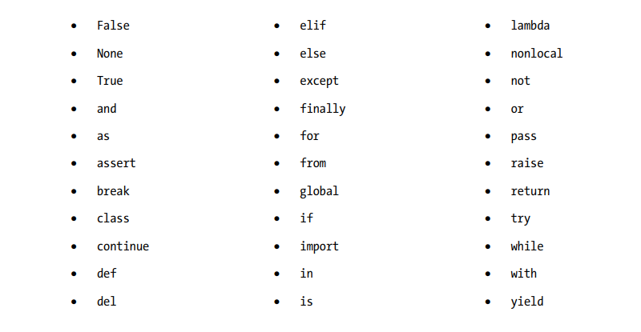

**Using Special Whitespace Characters**

It is also possible to specify whitespace characters using a character sequence that begins with a backslash, as shown in Table 3-1. \n produces a linefeed (LF) character; this is subtly different from the \r carriage return (CR): On a mechanical typewriter, the linefeed would just give you a new line, while the carriage return would properly start a new paragraph. One of the instances where you might need to know the difference is translating text files from one operating system to another: OS X uses the CR character at the end of lines, whereas Unix and Linux use the LF character, and Windows uses both.

The meaning and usage of some of these sequences is somewhat lost in the mists of time. Mostly, you’ll want to use the \n escape. The other most useful one is \t, which produces a tab character that can be useful for quick-and-dirty indentation of text. Most of the other whitespace characters are only likely to be useful in very specialized situations Below.

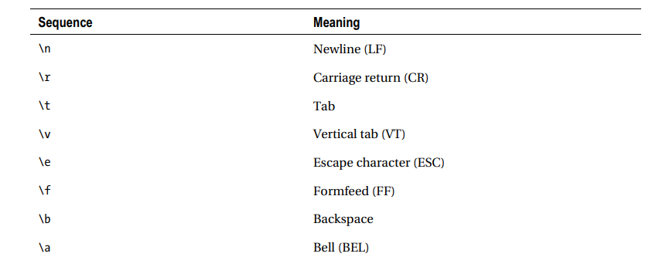

**Some More Useful Definitions:**

• Binary (base 2): Binary arithmetic uses the digits 0 and 1. This corresponds to the electric current in a wire, which can only be on (value 1) or off (value 0)

• Bit: A bit is a digit in the binary number system. It can have two values, 0 or 1. The word is derived from binary digit.

• Boolean: Variables of this type can take only one of two values, True and False. These correspond to 1 and 0. This is the most appropriate return type for a function that uses its return value to report whether some condition holds or not.

• Built-in: Anything built-in is innate part of the programming language, as opposed to something that has to be imported from a module. A built-in element is part of Python’s standard library.

• Byte: A byte is the smallest unit of storage that can be accessed in a computer’s memory. It holds exactly 8 bits.

• Case-sensitive: In case-sensitive text, uppercase letters are treated as completely different characters from their lowercase counterparts. Treating uppercase and lowercase variants as the same character is known as case-insensitive.

• Characters: These are letters, digits, punctuation marks, and spaces—basically anything that can be typed in using a single key on the keyboard, even if it doesn't cause anything to be printed on the screen.

• Concatenate: When you create a string by joining together copies of two or more text strings without any spaces in between, you concatenate the string.

• Decimal (base 10): Decimal numbers are what you probably think of as normal numbers.

• Dynamic typing: Python determines the type and checks the correct usage of variables of different types during execution of a program rather than during compilation. Some other programming languages, like C, are statically typed: the compiler will not allow the use of a variable or function unless that function or variable has already been initialized and declared to be of a certain type. You don’t need to bother with declaring the type of your variables in Python.

• Expression: This refers to a section of code that can be worked out to produce a value.

• Flag: A flag is a Boolean variable used to record whether or not something has happened.

• Float: Float is short for “floating point” and is a fundamental type used to define numbers with fractional parts.

• Hexadecimal (base 16): Hexadecimal is base 16 arithmetic where each digit is a value from 0 to 15, rather than the 0 to 9 of base 10. The decimal numbers from 10 to 15 are represented by the letters A to F. Hexadecimal is a very convenient way of showing binary numbers, as every four binary digits can be shown as one hexadecimal digit.

• Integer: An integer is a fundamental (i.e., built-in) type used to define numeric variables holding whole numbers.

• Immutable: An immutable value cannot be modified.

• Logical operator: These commands perform basic manipulations on Boolean values.

• Mapping: In Python, a mapping is a data type that relates a set of keys to a set of values. It has nothing to do with planning your car journey.

• Octal (base 8): In octal arithmetic, each digit has a value of 0 to 7.

• Operator: These are commands, often represented by mathematical symbols, that perform simple manipulations on data, known as operands. Expressions take the following form: operand1 operation operand2.

• Operator precedence: This is the order in which operators are assigned their arguments when Python evaluates an expression. Where there is ambiguity, the operator with the higher precedence is assigned as arguments the smallest expressions on either side of it that make sense.

• Sequence: In Python, a sequence is an instance of a data type that consists of more than a single item. It does not refer to a series of statements to be executed one after another as in some other languages.

• Statement: This refers to a section of code that does something such as manipulate a piece of data, perform a calculation, or produce some output.

• String literal: This refers to words and sentences, and text composed of these, that is, any form of literal text.

• Truth testing: Evaluate whether a condition is True or False.

**CHAPTER-4**

**Making Choices**

So far, you have learned how to enter commands and information and get some output returned, using fundamental data types: text strings, numbers, and Booleans. You have learned how to use Python as a pocket calculator, but most importantly, you have learned how to start designing your own software. Now, it is time to begin the process of refining your designs. As you learn more about Python and practice your logic juggling skills, you are likely to find simpler and more effective ways of coding your designs, and you will want to update your old scripts. This is a normal and natural part of the process of program design and a good discipline to develop early on.

Following this train of thought, in this chapter we’re going to see some techniques to improve our previous work. I’ll explain how to compare values in your code so that you can make decisions and take appropriate actions based on the comparison. This approach to controlling the flow of your application will allow your applications to be more flexible and able to deal with changing input. With this flexibility, however, comes complexity, so I’ll go over how to manage increasingly complex code.

The final part of the chapter covers loops, which are another way to alter the flow of your application. With loops, you can iterate over a large set of data and perform the same operations on each member of the set.

**Comparing Things**

The curtain-making exercise at the end of the previous chapter needs some refining. It is too simplistic to provide accurate answers and contains some logical errors that need fixing. In order to generate more accurate answers, you need to know how to compare values and specify different courses of action based on the results. The code construction that allows us to do this is called a conditional statement. Conditional statements transform the script from being just a list of instructions to something that can make decisions on the fly based on the information that it receives. It would be useful to be able to tell the program to perform different actions according to whether certain conditions are satisfied. You could write this out in pseudocode like this:

if one condition is true:

then perform one set of actions;

if another condition is true:

then perform another set of actions.

Each if-then pair is a conditional statement. Before we get into that, let’s look at how to specify conditions.

Values can be compared using the following comparison operators:

• <=: Less than or equal

• >: Greater than

• >=: Greater than or equal

• ==: Equal

• ! =: Not equal

These affect the fundamental data types in different ways, each time giving us an answer of True or False. Operands are the bits of data on the left and right of the operator in an expression. The operands on either side of the comparison operator must be of types that can be compared. The operands and the comparison operator together are a conditional expression.

Python might not throw an error if you compare illogical types, so it is a good idea to test your conditional expressions thoroughly and check the data that goes into them. The results obtained from comparing numbers using conditional expressions in interactive mode are fairly self-explanatory.

Here is some example

>>> -2 < 5 >>> 49 > 37 >>> 7.65! = 6.0

True True True

>>> -5 <= -2 >>> 7 < -7 >>> 23.5 > 37.75

True False False

>>> -5 >= 5 >>> 3.2! = 3.2

False False

You can also create conditional expressions using variables.

>>> variable = 3.0

>>> variable == 3 True

Also, strings can be compared alphabetically using the same comparison operators:

>>> "alpha" < "omega" >>> "case" == "Case"

True False

>>> "net" < "network" >>> "Same”! = "Same"

True False

Notice that uppercase characters don’t count the same as their lowercase counterparts. All of the uppercase letters come before any of the lowercase. If you are not familiar with this method of sorting, the order is laid out in bellow Figure.

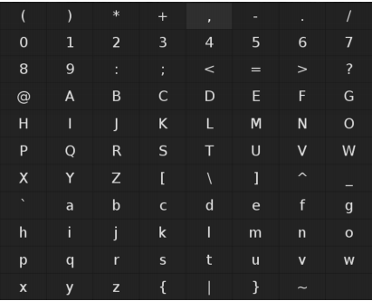

Case-sensitive alphabetical ordering

If you want to compare strings according to their lengths, you would need to use the built-in len() function.

>>> len("alpha") < len("omega") >>> len("case") == len("Case")

False True

>>> len("net") < len("network") >>> len("Same") != len("Same")

True False

**Combining Conditional Expressions**

Conditional expressions can be combined to produce relatively complex conditions using the logical operators, and and or. For example, we can check if two conditions are true:

(var1 < 6) and (var2 > 7)

This will return True only if var1 is less than 6 and var2 is greater than 7. We can also use or:

(var1 < 6) or (var2 > 7)

This returns True if either of the conditions are satisfied.

height, length = length, height

You can also assign the same value to several different variables.

x = y = z = 1

The assignment operator can be used in conjunction with most arithmetic operators to modify a variable in place. For example, you could type

counter += 1

which is the same as counter = counter + 1. Some other possible combinations are -=, *=, /=, which decrease the value of the variable by the specified amount, multiply the value of the variable by the specified amount, and divide the value of the variable by the specified amount.

**Understanding Operator Precedence**

As discussed in the previous chapter, the order in which you use operators does matter. The best way to avoid confusion or unwanted results in your scripts is to use parentheses to dictate which order the subexpressions should be evaluated.

>>> 2 + 3 * 6 + 4 / 2 + 3 >>> (2 + 3) * (6 + 4) / (2 + 3) >>> 2 + (3 * (6 + 4) / 2) + 3

25.0 10.0 20.0

The interpreter will evaluate the expression in the innermost set of brackets first. Otherwise, operators will be evaluated in the order shown in Table 4-1, which includes some additional operators that will be discussed later in this book. The important thing to note here is that arithmetical operators have a higher precedence than comparison operators, so the sums are done first, before they are compared, and only then are the effects of not, and, and or evaluated. Expressions that are equal in precedence are evaluated from left to right, except for comparisons, which are chained: 2 + 3 + 4 evaluates as (2 + 3) + 4, but 2 < 3 < 4 evaluates as (2 < 3) and (3 < 4).

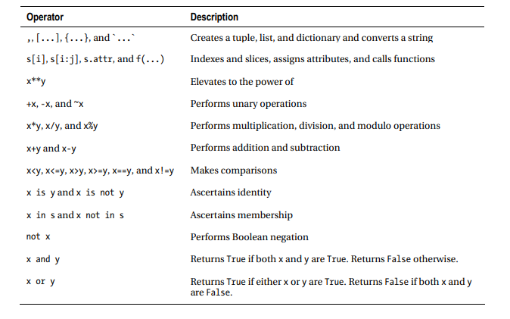

**CHAPTER-5**

**Using Lists**

In this chapter, you will learn how to deal with multiple items of data by processing them in sequence. First, I’ll give you an overview of the data structures that Python provides that can contain more than one item. These include Strings, tuples, lists and dictionaries. There are a few actions that you can perform on all of these data types, so I’ll cover those before going into the details of creating and manipulating each type separately. In the second half of this chapter, you’ll be making a simple roleplaying combat game. You will use these data structures to contain your player’s statistics and inventory and to translate the numerical results of the combat calculations into descriptive phrases. You’ll be using what you learned about loops in the previous chapter to work with the individual items in those data structures. In the process, I’ll cover some of the design and development issues you may have to face when creating more complex applications, and you’ll see how Python can be used to make repetitive number-crunching and text manipulation not only fast and painless but also entertaining!

**Working with Python Data Structures**

So far, you have learned to work with individual pieces of data to produce some simple results. Real-world data is usually in lumps or groups, and it would be useful to work with such groups without having to make lots of repetitive statements in our code. Fortunately, Python provides a variety of data types that can make handling groups of data much simpler.

The data types that are most used in Python are strings, tuples, lists and dictionaries. These are collectively called data structures.

Strings are just pieces of text. Tuples and lists are ordered groups of individual data items. Dictionaries are groups of key-value pairs.

Strings, tuples, and lists are examples of a particular data model called sequences. The methods used for accessing the data in a sequence are same, which you will see later in this chapter.

There is another way of looking at these data types—according to whether they can be modified or not, which is called mutability. Strings and tuples are immutable, which means that we cannot modify an existing string or tuple, although we can use them to create new strings and tuples, respectively. Lists are mutable, which means we can add or remove items from a list.

**Accessing the items in a sequence**

We can fetch an individual item from a sequence using an index, which is the position of the element. The index is specified as an integer (a whole number) in square brackets immediately following the variable name. So, s[i] will retrieve the item at position i of sequence s. This allows you to access a single character in a string:

>>> fruit = 'apple'

>>> fruit [0]

'a'

or an item in a list or tuple:

>>> fruits = ['avocados', 'bananas', 'oranges', 'grapes', 'mangos']

>>> fruits[2]

'oranges'

The first thing you will notice is that indexing is zero-based; that means you start counting at 0. An index of [2] accesses the third item in the list, the first item would be referenced with [0]. So you can use integers 0 through to the number of elements in the sequence minus one (0 to n – 1) as indices. Negative indices count backward from the end:

>>> fruits[-1]

'mangos'

You can grab sections of a sequence using slices. Slicing is used to fetch multiple items from a sequence. Slices are written using the same notation as an index, but this time with two or three integers separated by colons. The first value is the inclusive starting point and the second number is the exclusive end point of the slice. So s[0:2] means that the slice will start from index 0 and stop just before index 2, (i.e., fetch items at positions 0 and 1).

The third value is optional and specifies an additional step value, which may be negative, so instead of picking out a sequential list, you can retrieve every other, or every nth item, and you can also retrieve them backward if you need to. So s[i:j:step] will retrieve a slice of s starting from i and up to, but not including j, and taking the specified step.

>>> fruits = ['avocados', 'bananas', 'oranges', 'grapes', 'mangos']

>>> fruits[2:-2]

['oranges']

>>> fruits[2:4]

['oranges', 'grapes']

>>> fruits[1:4:2]

['bananas', 'grapes']

If the starting point, i, is equal to or greater than end point, j, the slice you get back will be empty.

>>> fruits[4:4:2]

[]

I f you leave out the starting point, the slice will start at the beginning of the original sequence, and if you leave out the end point, the slice will run to the end of the original sequence.

Indexing and slicing do not modify the original sequence; they make a new sequence from the original. However, the actual individual data items are the same. So, if you modify an individual item in a sequence, you will see the item change in a slice from the sequence as well.

**If You’re Not on the List, You Can’t Come In**

Often, you will want to find out whether a particular piece of data is in a sequence or not. This is achieved in Python using the keyword in, which is a Boolean operator that tests for membership in a sequence. The test x in s will return True if x is in sequence s; otherwise, it will return False.

>>> 'apple' in fruits

False

It is possible to use not in conjunction with in to produce the opposite answer.

>>> 'apple' not in fruits

True

You can also use this operator on strings to find out whether x is contained in (i.e., is a substring of) string s.

>>> 'ana' in 'banana'

True

You can use the + operator to combine sequences to make a new sequence.

>>> 'pine' + 'apple' 'pineapple'

You can also use the * operator on sequences to create multiple copies glued together.

>>> 'heart'*5

'heartheartheartheartheart'

The best method for joining strings in a sequence is separator.join(seq). It uses an apparently bizarre notation, which deserves a little further explanation. You will have gathered by now that the different data types all have a different set of operations that can be used with them. These operations can be carried out by operators or methods.

Operators are commands written as a symbol (+, -, etc.) or keyword (in, and, or, etc.) between two operands. Methods are accessed using a command that follows the variable name immediately after a period (dot) and terminates in parentheses, which may or may not contain further arguments. In separator. Join(seq), join() is the method. Methods are like functions that are specific to an object, such as a data type in this instance (objects are covered in Chapters 9 and 10). For now, objects are specific instances of data types.

The string type has the method join(), which takes a sequence as an argument and returns a single string made up of the elements of the sequence joined together with copies of the original string between them. It might seem more logical to write sequence.join(separator), but that would be a method belonging to the separator type. Try reading the statement backward if you have trouble making sense of this:

>>> ", ".join(fruit)

'avocados, bananas, oranges, grapes, mangos'

You could pretty this up by assigning sep = ", " first and then calling sep.join(fruit) if you prefer; this could be useful if you are using the same separator elsewhere and you want to make sure that you are splitting and joining all your lists with the same separator. Readability of code is an important consideration. The assignment in the following example could be to vegetables.split(sep) in this case.

Splitting up a string to form a list can be done with string To Split. Split(separator), which is much more logical to write. This is a string method, so it works on a string variable. This method takes an additional argument that specifies the maximum number of splits allowed.

>>> vegetables = "carrots, potatoes, onions, leeks, celery"

>>> vegetables = vegetables. Split (", ")

>>> vegetables

['carrots', 'potatoes', 'onions', 'leeks', 'celery']

The preceding code allows to you process each word in a sentence separately, which can prove to be a useful technique.

There are a few useful built-in ways to convert sequences into different types of sequences. First, list(seq) turns any sequence into a list; if you do this with a string, you’ll get a list of the individual characters:

>>> list('banana')

['b', 'a', 'n', 'a', 'n', 'a']

>>> list(vegetables)

['carrots', 'potatoes', 'onions', 'leeks', 'celery']

If you want to turn a sequence into a tuple, the same rules apply to tuple(seq).

>>> tuple(vegetables)

('carrots', 'potatoes', 'onions', 'leeks', 'celery')

Converting a list into a string will make a readable text representation of the list.

>>> str(vegetables) "['carrots', 'potatoes', 'onions', 'leeks', 'celery']"

If you want to know how many elements a sequence has, use len(seq).

>>> len(vegetables)

5

The number of items in a sequence that are equal to x can be counted up with sequence.count(x). In other words, it counts each item where x == item is true.

>>> vegetables.count('carrot')

1

If you want to retrieve the greatest item in a sequence, use max(seq).

>>> max(vegetables)

'potatoes'

The least item can be accessed similarly with min(seq).

>>> min(vegetables)

'carrots'

It may be worth taking a moment to consider the results of the last two examples. Were they what you expected? The results came out based on alphabetical order. It seems that sequences have some kind of implicit sort order, even if they haven’t been sorted yet. It turns out that it is possible to use this implied order to compare sequences using the same comparison operators that are used to compare the fundamental data types.

>>> fruits > vegetables >>> vegetables > fruits >>> vegetables == fruits

False True False

The sequences fruits and vegetables both contain five members. Nevertheless, the Python interpreter is able to determine that the two sequences are not the same and decide that one is greater, as a whole, than the other.

Note that empty sequences will always return False in when tested in Boolean expressions. This is where the similarities between strings, tuples, and lists end.

**Tuples**

A tuple is an immutable ordered group of items or elements. Think of tuples as useful little sealed packets of information.

A tuple is specified as a comma-separated list of values, which may be enclosed in parentheses. On certain occasions, the parentheses are required, so when in doubt, use parentheses. The values need not all be of the same type. A value can also be another tuple.

**Creating a Tuple**

You can create a tuple with zero items using an empty pair of round brackets ().

>>> blank_tuple = ()

If you want to make a tuple that only contains one item, you must follow the item with a single comma (item,).

>>> single_tuple = ('item',)

Tuples are normally created by assigning a sequence of comma-separated values to a variable, which is known as sequence packing. Notice that we don’t need parentheses in this example, because it is unambiguous that it is a tuple:

>>> t = 'blah1', 'blah2', 'blah3'

The sequence can be unpacked by doing the reverse:

>>> blah1, blah2, blah3 = t

**Changing the Values in a Tuple**

You can’t. That’s not what they’re meant for. Remember when we said they are useful little sealed packets of information? They are used mostly in situations where a set of values has to be passed on to another place without worry of having them messed about. You can also use them to provide dictionary keys. If you want a sequence of data that you can change, then you need a list.

**Lists**

A list is an ordered, comma-separated list of items enclosed in square brackets. Items need not all be of the same type. An item can also be another list.

Lists can be sliced, concatenated, and indexed the same as any other type of sequence. It is possible to change individual items in a list, as opposed to immutable strings and tuples. Where a tuple is rather like a fixed menu, lists are more flexible. It is possible to assign data to slices, which can change the size of the list or clear it completely.

**Creating a List**

Lists are easy to create:

>>> inventory = ['pole', ['another', 'list'], 'silver mirror', '10 gold coins', 'potion']

**Modifying a List**

New values can be assigned to list items using the assignment operator sequence[i] = x.

>>> inventory[1] = 'wax'

>>> inventory

['pole', 'wax', 'silver mirror', '10 gold coins', 'potion']

You can replace a slice of your list with another sequence using list[i:j:step] = sequence.

>>> inventory[::2] = ['shield', 'scroll', 'oil']

>>> inventory

['shield', 'wax', 'scroll', '10 gold coins', 'oil']

Here, I have specified a slice with no start or end point and a step size of two, so every other item in the whole list is affected by this change.

You can add elements to a list by using the append() or extend() methods, the append() method adds individual items; the extend() method is used to add items from another list:

>>> inventory.append('skull')

>>> inventory

['shield', 'wax', 'scroll', '10 gold coins', 'oil', 'skull']

>>> inventory.extend(['sword', 'oil'])

>>> inventory ['shield', 'wax', 'scroll', '10 gold coins', 'oil', 'skull', 'sword', 'oil']

The keyword del can be used to remove entire variables or slices of a list. Remember that this only removes references from the list; the actual item itself is not affected if they are still being used in other data structures.

>>> del inventory[4:]

>>> inventory

['shield', 'wax', 'scroll', '10 gold coins']

You can get the index position of the first item that corresponds to x using list.index(x).

>>> inventory. Index('scroll')

2

You can insert an item x at position i with list.insert(i,x).

>>> inventory.insert(2,'wand')

>>> inventory

['shield', 'wax', 'wand', 'scroll', '10 gold coins', 'emerald', 'pole', 'potion']

You can also remove the first item that is equal to x in list s using list.remove(x).

>>> inventory.remove('wax')

>>> inventory

['shield', 'wand', 'scroll', '10 gold coins', 'emerald', 'pole', 'potion']

Sometimes, you may want to remove and return a value from the list at the same time. This can be done using list.pop(i). This method takes an index position as an argument. If the index is not specified, it defaults to the last item in the list.

>>> inventory.pop(-2)

'pole'

>>> inventory

['shield', 'wand', 'scroll', '10 gold coins', 'emerald', 'potion']

**CHAPTER-6**

**Python NumPy**

**What is numpy?**

Numpy is a general-purpose array-processing package. It provides a high-performance multidimensional array object, and tools for working with these arrays. It is the fundamental package for scientific computing with Python.

Besides its obvious scientific uses, Numpy can also be used as an efficient multi-dimensional container of generic data.

It is the fundamental package for scientific computing with Python. It contains various features including these important ones:

* A powerful N-dimensional array object
* Sophisticated (broadcasting) functions
* Tools for integrating C/C++ and Fortran code
* Useful linear algebra, Fourier transform, and random number capabilities

**Installation:**

Windows, Mac and Linux users can install NumPy via pip command:

pip install numpy

**Arrays in Numpy**

Array in Numpy is a table of elements (usually numbers), all of the same type, indexed by a tuple of positive integers. In Numpy, number of dimensions of the array is called rank of the array. A tuple of integers giving the size of the array along each dimension is known as shape of the array. An array class in Numpy is called as ndarray. Elements in Numpy arrays are accessed by using square brackets and can be initialized by using nested Python Lists.

**Creating a Numpy Array**

Arrays in Numpy can be created by multiple ways, with various number of Ranks, defining the size of the Array. Arrays can also be created with the use of various data types such as lists, tuples, etc. The type of the resultant array is deduced from the type of the elements in the sequences.

Note: Type of array can be explicitly defined while creating the array.

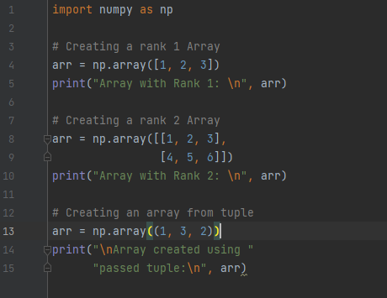

**O/P**

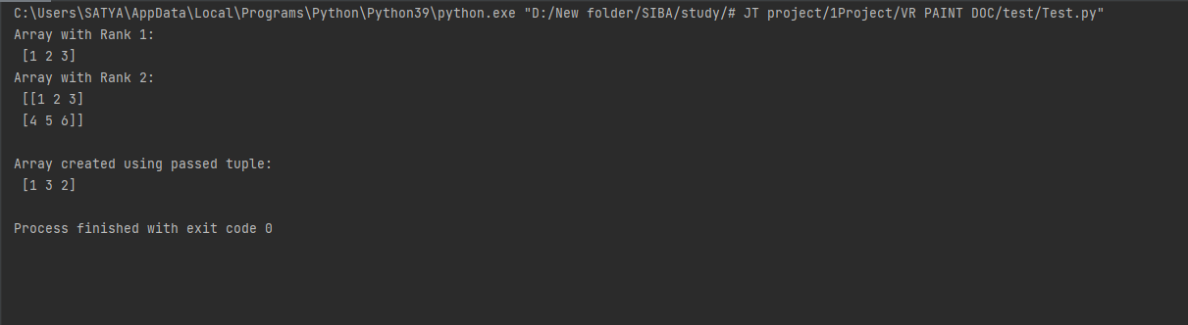

**Accessing the array Index**

In a numpy array, indexing or accessing the array index can be done in multiple ways. To print a range of an array, slicing is done. Slicing of an array is defining a range in a new array which is used to print a range of elements from the original array. Since, sliced array holds a range of elements of the original array, modifying content with the help of sliced array modifies the original array content.

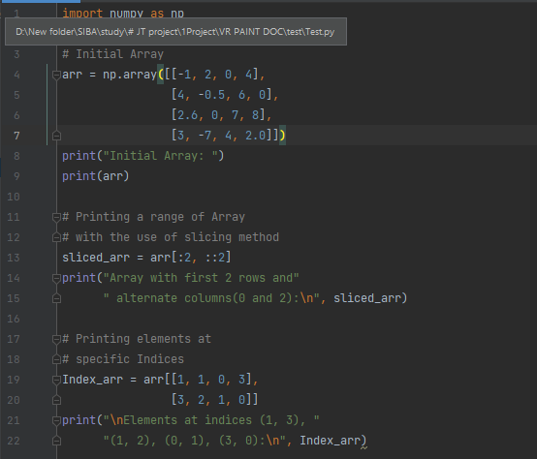

**O/P**

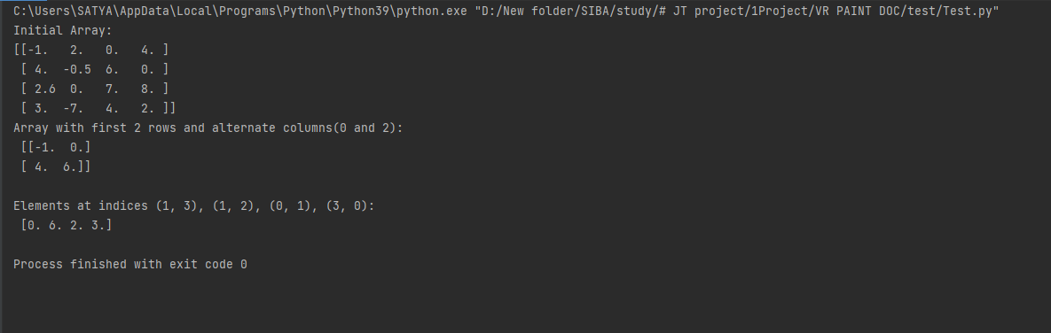

**Basic Array Operations**

In numpy, arrays allow a wide range of operations which can be performed on a particular array or a combination of Arrays. These operations include some basic Mathematical operation as well as Unary and Binary operations.

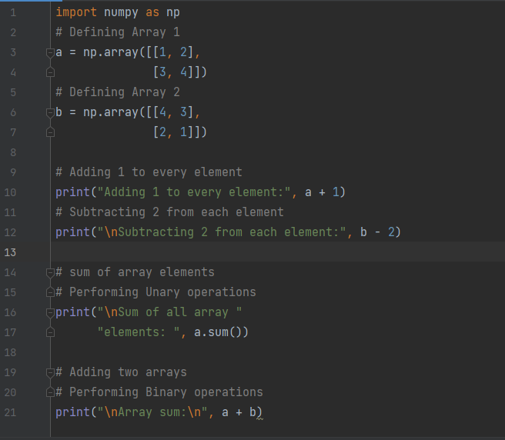

**O/P**

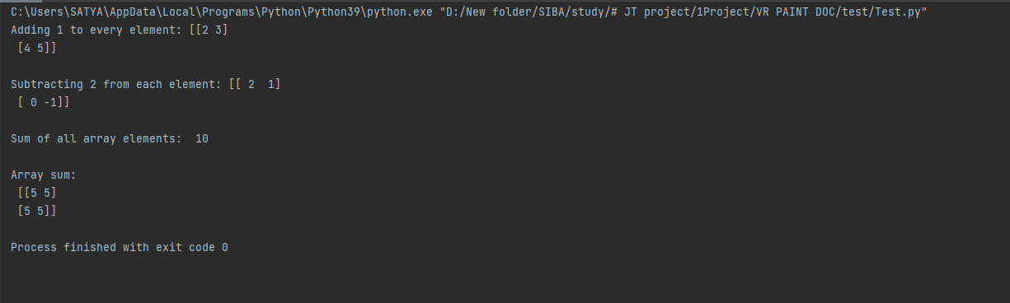

**Data Types in Numpy**

Every Numpy array is a table of elements (usually numbers), all of the same type, indexed by a tuple of positive integers. Every ndarray has an associated data type (dtype) object. This data type object (dtype) provides information about the layout of the array. The values of an ndarray are stored in a buffer which can be thought of as a contiguous block of memory bytes which can be interpreted by the dtype object. Numpy provides a large set of numeric datatypes that can be used to construct arrays. At the time of Array creation, Numpy tries to guess a datatype, but functions that construct arrays usually also include an optional argument to explicitly specify the datatype.

**Methods in Numpy**

all() any() take() put() apply_along_axis()

apply_over_axes() argmin() argmax() nanargmin() nanargmax()

amax() amin() insert() delete() append()

around() flip() fliplr() flipud() triu()

tril() tri() empty() empty_like() zeros()

zeros_like() ones() ones_like() full_like() diag()

diagflat() diag_indices() asmatrix() bmat() eye()

roll() identity() arange() place() extract()

compress() rot90() tile() reshape() ravel()

isinf() isrealobj() isscalar() isneginf() isposinf()

iscomplex() isnan() iscomplexobj() isreal() isfinite()

isfortran() exp() exp2() fix() hypot()

absolute() ceil() floor() degrees() radians()

npv() fv() pv() power()

float_power() log() log1() log2() log10()

dot() vdot() trunc() divide()

floor_divide() true_divide() random.rand() random.randn()

ndarray.flat() expm1() bincount() rint() equal()

not_equal() less() less_equal() greater()

greater_equal() prod() square() cbrt() logical_or()

logical_and() logical_not() logical_xor() array_equal()

array_equiv() sin() cos() tan()

cosh() tanh() arcsin() arccos()

arctan() arctan2() sinh()

**CHAPTER-7**

**Introduction to OpenCV-Python Tutorials**

**OpenCV-Overview**

Computer vision is a process by which we can understand the images and videos how they are stored and how we can manipulate and retrieve data from them. Computer Vision is the base or mostly used for Artificial Intelligence. Computer-Vision is playing a major role in self-driving cars, robotics as well as in photo correction apps.

OpenCV is the huge open-source library for the computer vision, machine learning, and image processing and now it plays a major role in real-time operation which is very important in today’s systems. By using it, one can process images and videos to identify objects, faces, or even handwriting of a human. When it integrated with various libraries, such as NumPy, python is capable of processing the OpenCV array structure for analysis. To Identify image pattern and its various features we use vector space and perform mathematical operations on these features.

The first OpenCV version was 1.0. OpenCV is released under a BSD license and hence it’s free for both academic and commercial use. It has C++, C, Python and Java interfaces and supports Windows, Linux, Mac OS, iOS and Android. When OpenCV was designed the main focus was real-time applications for computational efficiency. All things are written in optimized C/C++ to take advantage of multi-core processing.

**Look at the following images**



**Here is the original Image**

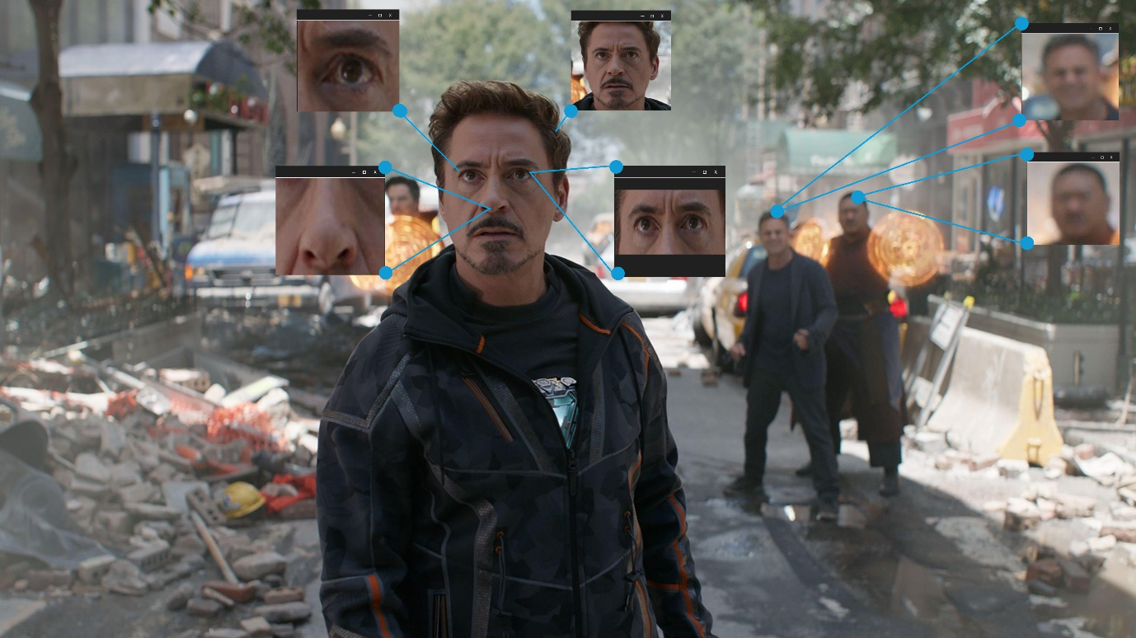

from the above original image, lots of pieces of information that are present in the original image can be obtained. Like in the above image there are two faces available and the person(I) in the images wearing a bracelet, watch, etc. so by the help of OpenCV we can get all these types of information from the original image.

It’s the basic introduction to OpenCV we can continue the Applications and all the things in our upcoming articles.

Applications of OpenCV: There are lots of applications which are solved using OpenCV, some of them are listed below

* face recognition
* Automated inspection and surveillance
* number of people – count (foot traffic in a mall, etc)
* Vehicle counting on highways along with their speeds
* Interactive art installations
* Anamoly (defect) detection in the manufacturing process (the odd defective products)
* Street view image stitching
* Video/image search and retrieval
* Robot and driver-less car navigation and control
* object recognition
* Medical image analysis
* Movies – 3D structure from motion
* TV Channels advertisement recognition

OpenCV Functionality

* Image/video I/O, processing, display (core, imgproc, highgui)
* Object/feature detection (objdetect, features2d, nonfree)
* Geometry-based monocular or stereo computer vision (calib3d, stitching, videostab)
* Computational photography (photo, video, superres)
* Machine learning & clustering (ml, flann)
* CUDA acceleration (gpu)

**History of OpenCV**

OpenCV was started at Intel in 1999 by Gary Bradsky and the first release came out in 2000. Vadim Pisarevsky joined Gary Bradsky to manage Intel’s Russian software OpenCV team. In 2005, OpenCV was used on Stanley, the vehicle who won 2005 DARPA Grand Challenge. Later its active development continued under the support of Willow Garage, with Gary Bradsky and Vadim Pisarevsky leading the project. Right now, OpenCV supports a lot of algorithms related to Computer Vision and Machine Learning and it is expanding day-by-day.

Currently OpenCV supports a wide variety of programming languages like C++, Python, Java etc and is available on different platforms including Windows, Linux, OS X, Android, iOS etc. Also, interfaces based on CUDA and OpenCL are also under active development for high-speed GPU operations.

OpenCV-Python is the Python API of OpenCV. It combines the best qualities of OpenCV C++ API and Python language.

**OpenCV-Python**

Python is a general-purpose programming language started by Guido van Rossum, which became very popular in short time mainly because of its simplicity and code readability. It enables the programmer to express his ideas in fewer lines of code without reducing any readability.

Compared to other languages like C/C++, Python is slower. But another important feature of Python is that it can be easily extended with C/C++. This feature helps us to write computationally intensive codes in C/C++ and create a Python wrapper for it so that we can use these wrappers as Python modules. This gives us two advantages: first, our code is as fast as original C/C++ code (since it is the actual C++ code working in background) and second, it is very easy to code in Python. This is how OpenCV-Python works, it is a Python wrapper around original C++ implementation.

And the support of NumPy makes the task easier. NumPy is a highly optimized library for numerical operations. It gives a MATLAB-style syntax. All the OpenCV array structures are converted to-and-from NumPy arrays. So whatever operations you can do in NumPy, you can combine it with OpenCV, which increases number of weapons in your arsenal. Besides that, several other libraries like SciPy, Matplotlib which supports NumPy can be used with this.

So OpenCV-Python is an appropriate tool for fast prototyping of computer vision problems.

**OpenCV Needs You!!!**

Since OpenCV is an open-source initiative, all are welcome to make contributions to this library. And it is same for this tutorial also.

So, if you find any mistake in this tutorial (whether it be a small spelling mistake or a big error in code or concepts, whatever), feel free to correct it and that will be a good task for freshers who begin to contribute to open-source projects. Just fork the OpenCV in GitHub, make necessary corrections and send a pull request to OpenCV. OpenCV developers will check your pull request, give you important feedback and once it passes the approval of the reviewer, it will be merged to OpenCV. Then you become an open-source contributor. Similar is the case with other tutorials, documentation etc. As new modules are added to OpenCV-Python, this tutorial will have to be expanded. So those who knows about particular algorithm can write up a tutorial which includes a basic theory of the algorithm and a code showing basic usage of the algorithm and submit it to OpenCV.

**Contributors**

Below is the list of contributors who submitted tutorials to OpenCV-Python.

1. Alexander Mordvintsev (GSoC-2013 mentor)

2. Abid Rahman K. (GSoC-2013 intern)

**Image-Processing**

Image processing is a method to perform some operations on an image, in order to get an enhanced image and or to extract some useful information from it.

If we talk about the basic definition of image processing then “Image processing is the analysis and manipulation of a digitized image, especially in order to improve its quality”.

Digital-Image:

An image may be defined as a two-dimensional function f(x, y), where x and y are spatial(plane) coordinates, and the amplitude of fat any pair of coordinates (x, y) is called the intensity or grey level of the image at that point.

In another word An image is nothing more than a two-dimensional matrix (3-D in case of colored images) which is defined by the mathematical function f(x, y) at any point is giving the pixel value at that point of an image, the pixel value describes how bright that pixel is, and what color it should be.

Image processing is basically signal processing in which input is an image and output is image or characteristics according to requirement associated with that image.

Image processing basically includes the following three steps:

1. Importing the image
2. Analyzing and manipulating the image
3. Output in which result can be altered image or report that is based on image analysis

**Introduction to OpenCV**

OpenCV is one of the most popular computer vision libraries. If you want to start your journey in the field of computer vision, then a thorough understanding of the concepts of OpenCV is of paramount importance.

In this article, I will try to introduce the most basic and important concepts of OpenCV in an intuitive manner.

This article will cover the following topics:

1. Reading an image
2. Extracting the RGB values of a pixel
3. Extracting the Region of Interest (ROI)
4. Resizing the Image
5. Rotating the Image
6. Drawing a Rectangle
7. Displaying text

**How to install OpenCV for Python in Windows**

In this tutorial We will learn to setup OpenCV-Python in your Windows system.

Below steps are tested in a Windows 10–64-bit machine with PyCharm and Visual Studio code.

OpenCV is the huge open-source library for computer vision, machine learning, and image processing and now it plays a major role in real-time operation which is very important in today’s systems. By using it, one can process images and videos to identify objects, faces, or even the handwriting of a human. When it integrated with various libraries, such as NumPy, python is capable of processing the OpenCV array structure for analysis. To Identify image patterns and its various features we use vector space and perform mathematical operations on these features.

To install OpenCV, one must have Python and PIP, preinstalled on their system. To check if your system already contains Python, go through the following instructions:

Open the Command line (search for cmd in the Run dialog (+ R).

Now run the following command:

Python --version

If Python is already installed, it will generate a message with the Python version available.

If not install then go to python website <https://www.python.org/> and download if for windows

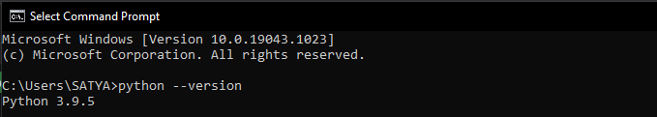

Downloading and Installing OpenCV:

OpenCV can be directly downloaded and installed with the use of pip (package manager). To install OpenCV, just go to the command-line and type the following command:

pip install opencv-python

If OpenCV already install then it shows like this & if the OpenCV doesn’t install it show something else

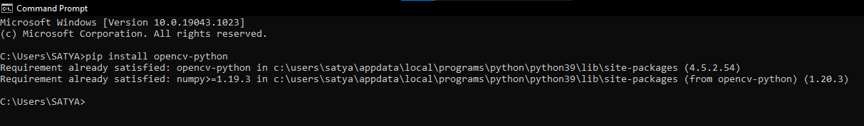

To check if OpenCV is correctly installed, just run the following commands to perform a version check:

py

>>>import cv2

>>>print(cv2.__version__)

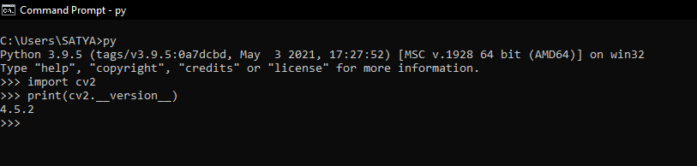

**Set up OpenCV with PyCharm environment**

If you love working on image processing and video analysis using python then you have come to the right place. Python is one of the major languages that can be used to process images or videos.

Requirements for OpenCV and PyCharm

– 32- or a 64-bit computer.

– For PyCharm—1000 MB disk space.

– For PyCharm—Minimum 2.5 GB disk space to download and install.

– Windows, macOS or Linux.

– Python 3.5,3.6, or 3.9.

Installing PyCharm: Head over to <https://www.jetbrains.com/pycharm/download/#section=windows> and install the latest version of PyCharm. Make sure to install the “Python 3.0 Upper Version” for the appropriate architecture. Install it with the default settings

**OPENCV**

OpenCV (Open-Source Computer Vision) is a computer vision library that contains various functions to perform operations on pictures or videos. It was originally developed by Intel but was later maintained by Willow Garage and is now maintained by Itrez. This library is cross-platform that is it is available on multiple programming language such as Python, C++ etc.

In upper steps OpenCV automatically connected to PyCharm. But in case it doesn’t connected to PyCharm hear below some steps through which it connected successfully.

First go to PyCharm setting, then go to Python interpreter Then Click the add button and search "opencv-python” and click install Package.

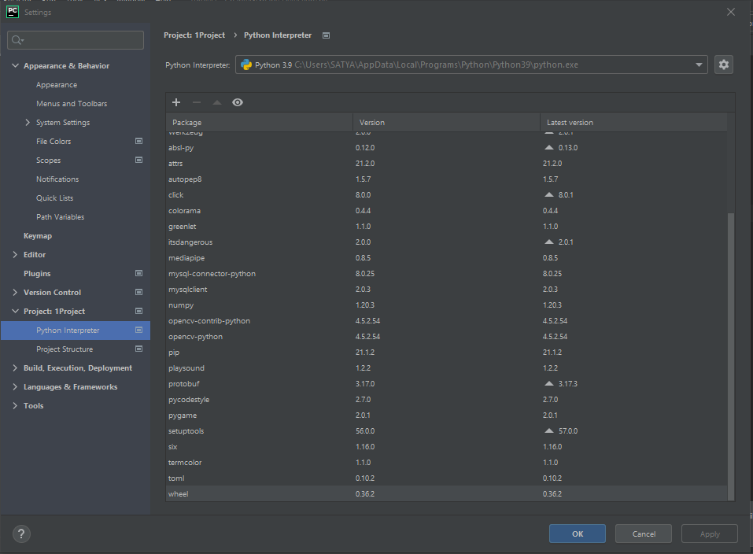

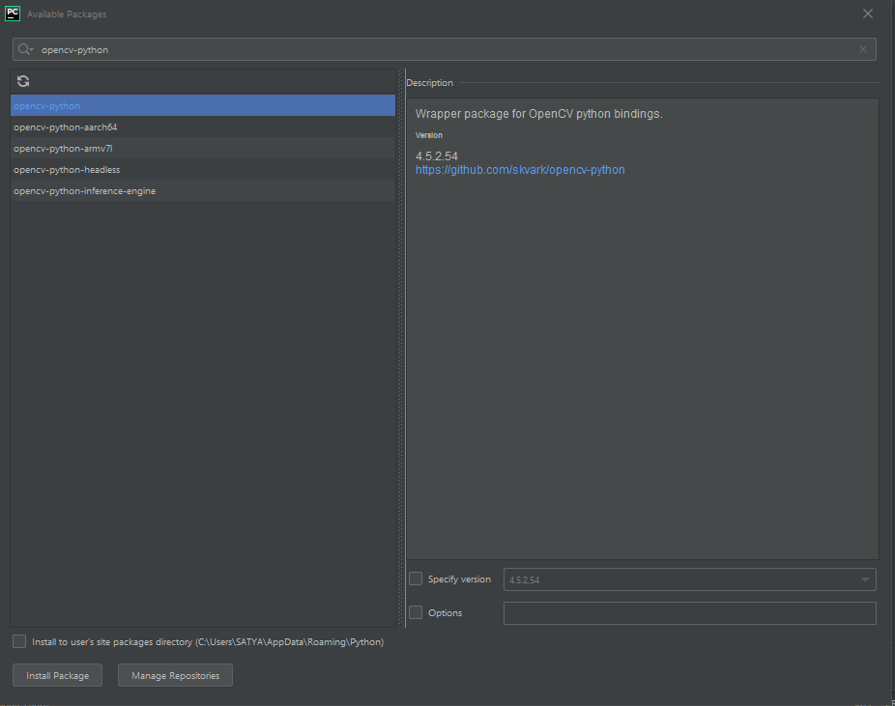

**Reading an image**

img = cv2.imread('LOCATION OF THE IMAGE')

The above function imread stores the image at the given location to the variable img.

**Showing the stored image**

cv2.imshow('image',img)

The above function shows the image stored in img variable.

**Reading video directly from the webcam**

cap = cv2.VideoCapture(0)

Stores live video from your webcam in variable cap.

**Reading a video from local storage**

cap = cv2.VideoCapture('LOCATION OF THE VIDEO')

Stores the video located in the given location to the variable.

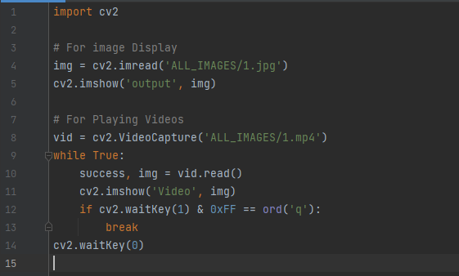

**Image Resizing using OpenCV Python**

Image resizing refers to the scaling of images. Scaling comes in handy in many images processing as well as machine learning applications. It helps in reducing the number of pixels from an image and that has several advantages e.g. It can reduce the time of training of a neural network as more is the number of pixels in an image more is the number of input nodes that in turn increases the complexity of the model.

It also helps in zooming in images. Many times, we need to resize the image i.e., either shrink it or scale up to meet the size requirements. OpenCV provides us several interpolation methods for resizing an image.

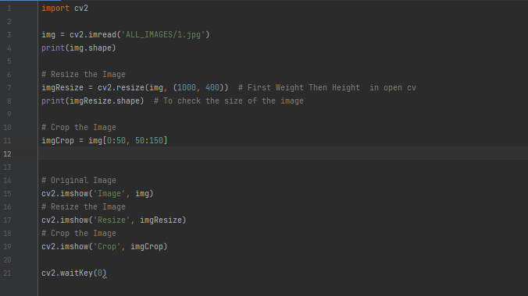

**Output**

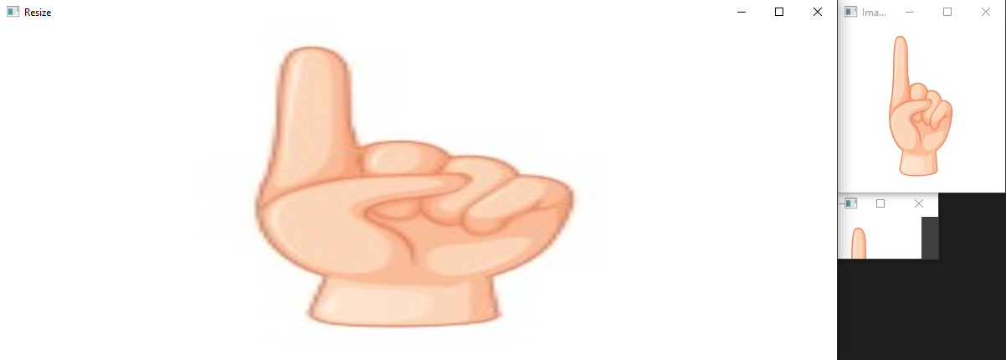

**Edge detection in an Image: -**

The process of image detection involves detecting sharp edges in the image. This edge detection is essential in context of image recognition or object localization/detection. There are several algorithms for detecting edges due to its wide applicability. We’ll be using one such algorithm known as Canny Edge Detection.

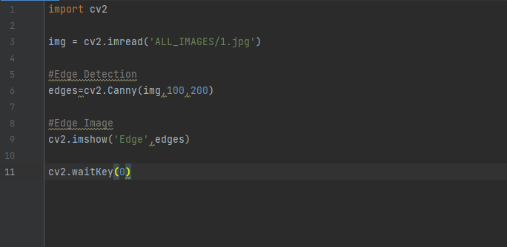

**O/P**

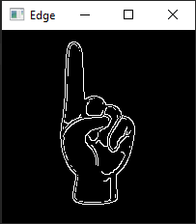

**Python Image blurring using OpenCV**

Image Blurring refers to making the image less clear or distinct. It is done with the help of various low pass filter kernels.

**Advantages of blurring:**

* It helps in Noise removal. As noise is considered as high pass signal so by the application of low pass filter kernel, we restrict noise.
* It helps in smoothing the image.
* Low intensity edges are removed.
* It helps in hiding the details when necessary. For e.g., in many cases police deliberately want to hide the face of the victim, in such cases blurring is required.

**Important types of blurring:**

* Gaussian Blurring: Gaussian blur is the result of blurring an image by a Gaussian function. It is a widely used effect in graphics software, typically to reduce image noise and reduce detail. It is also used as a preprocessing stage before applying our machine learning or deep learning models.
* Median Blur: The Median Filter is a non-linear digital filtering technique, often used to remove noise from an image or signal. Median filtering is very widely used in digital image processing because, under certain conditions, it preserves edges while removing noise. It is one of the best algorithms to remove Salt and pepper noise.
* Bilateral Blur: A bilateral filter is a non-linear, edge-preserving, and noise-reducing smoothing filter for images. It replaces the intensity of each pixel with a weighted average of intensity values from nearby pixels. This weight can be based on a Gaussian distribution. Thus, sharp edges are preserved while discarding the weak ones.

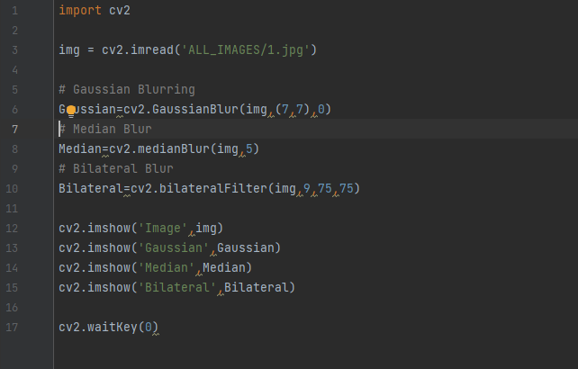

**O/P**

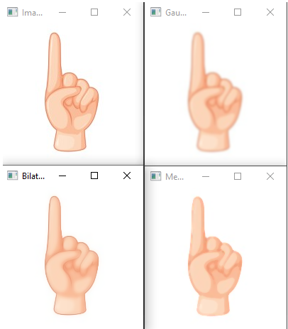

**Python OpenCV Draw Some Shapes**

**First draw a line using cv2.line() method**

OpenCV-Python is a library of Python bindings designed to solve computer vision problems.cv2.line() method is used to draw a line on any image.

Syntax: cv2.line(image, StartPoint, EndPoint, color, thickness)

Parameters:

* image: It is the Canvas on which line is to be drawn.
* StartPoint: It is the starting coordinates of line. The coordinates are represented as tuples of two values i.e. (X coordinate value, Y coordinate value).
* EndPoint: It is the ending coordinates of line. The coordinates are represented as tuples of two values i.e. (X coordinate value, Y coordinate value).
* color: It is the color of line to be drawn. For BGR, we pass a tuple. e.g.: (0, 255, 0) for Green color.
* thickness: It is the thickness of the line in px.
* Return Value: It returns an image.

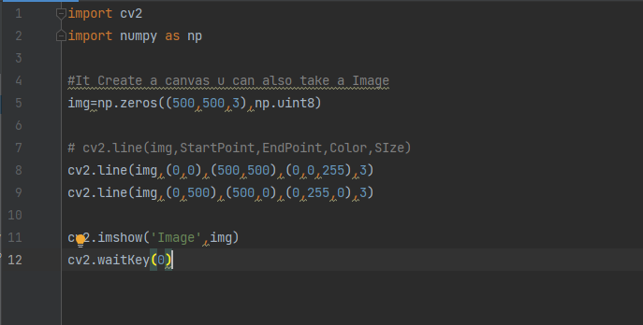

**O/P**

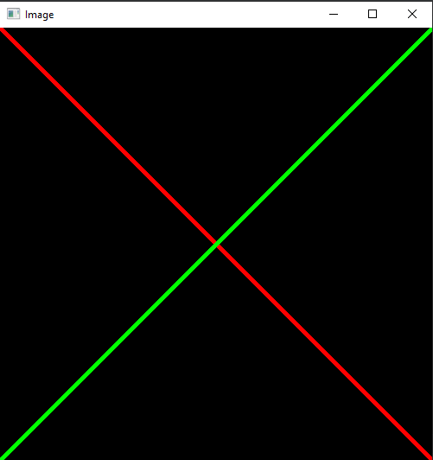

**Circle Detection using OpenCV Python**

**First, we know how to draw a Circle**

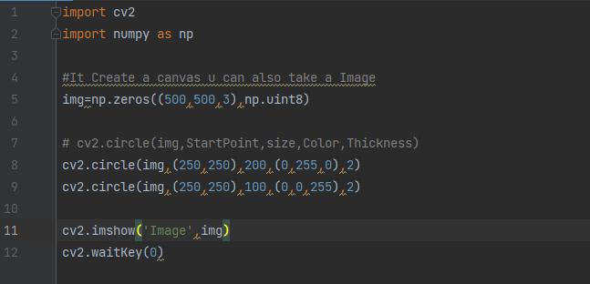

**O/P**

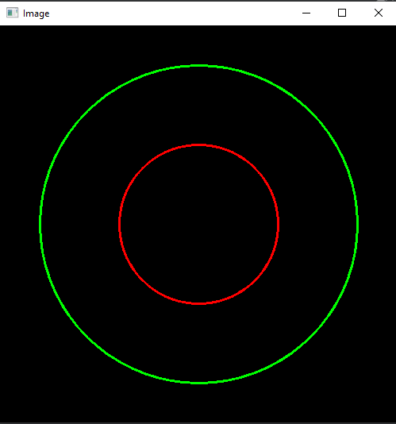

Circle detection finds a variety of uses in biomedical applications, ranging from iris detection to white blood cell segmentation. The technique followed is similar to the one used to detect lines.

**Basics of Circle Detection**

A circle can be described by the following equation:

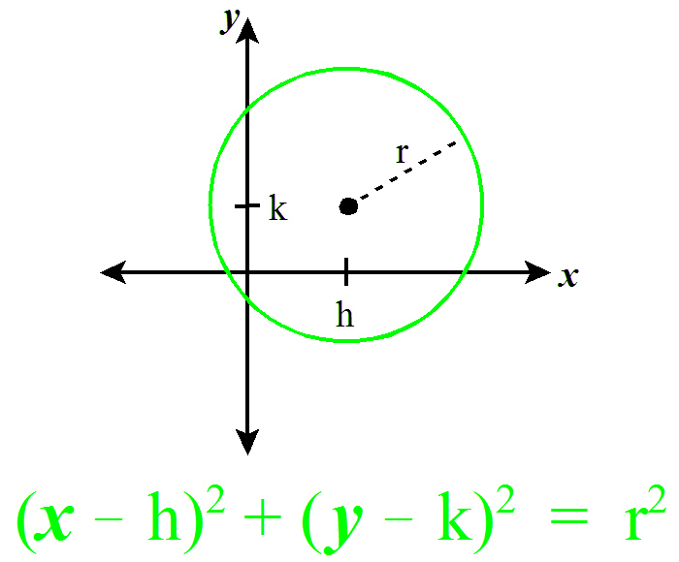

To detect circles, we may fix a point (x, y). Now, we are required to find 3 parameters: a, b and r. Therefore, the problem is in a 3-dimensional search space. To find possible circles, the algorithm uses a 3-D matrix called the “Accumulator Matrix” to store potential a, b and r values. The value of a (x-coordinate of the center) may range from 1 to rows, b (y-coordinate of the center) may range from 1 to cols, and r may range from 1 to maxRadius = 

**Below are the steps of the algorithm.**

* **Initializing the Accumulator Matrix:** Initialize a matrix of dimensions rows * cols * maxRadius with zeros.
* **Pre-processing the image:** Apply blurring, grayscale and an edge detector on the image. This is done to ensure the circles show as darkened image edges.
* **Looping through the points:** Pick a point xi on the image.
* **Fixing r and looping through a and b:** Use a double nested loop to find a value of r, varying a and b in the given ranges.
* **Voting:** Pick the points in the accumulator matrix with the maximum value. These are strong points which indicate the existence of a circle with a, b and r parameters. This gives us the Hough space of circles.
* **Finding Circles:** Finally, using the above circles as candidate circles, vote according to the image. The maximum voted circle in the accumulator matrix gives us the circle.

**The Hough Circles function in OpenCV has the following parameters which can be altered according to the image.**

* **Detection Method:** OpenCV has an advanced implementation, HOUGH_GRADIENT, which uses gradient of the edges instead of filling up the entire 3D accumulator matrix, thereby speeding up the process.
* **dp:** This is the ratio of the resolution of original image to the accumulator matrix.
* **minDist:** This parameter controls the minimum distance between detected circles.
* **Param1:** Canny edge detection requires two parameters — minVal and maxVal. Param1 is the higher threshold of the two. The second one is set as Param1/2.
* **Param2:** This is the accumulator threshold for the candidate detected circles. By increasing this threshold value, we can ensure that only the best circles, corresponding to larger accumulator values, are returned.
* **minRadius:** Minimum circle radius.
* **maxRadius:** Maximum circle radius.

**Below is the code for finding circles using OpenCV on the above input image.**

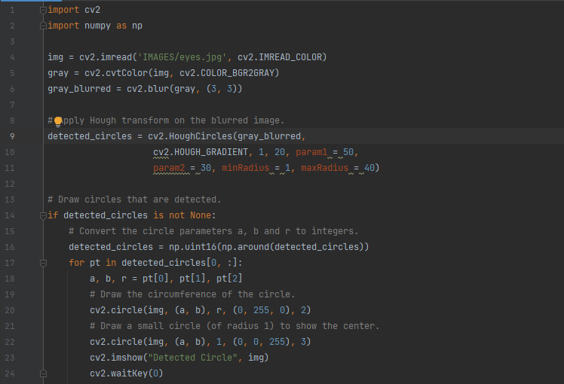

**O/P**

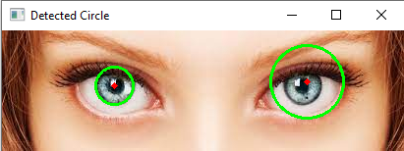

**Python OpenCV Enter Text cv2.putText() method**

OpenCV-Python is a library of Python bindings designed to solve computer vision problems. cv2.putText() method is used to draw

Syntax: cv2.putText(image, text, org, font, fontScale, color, [thickness], [lineType],[ bottomLeftOrigin])

Parameters:

image: It is the image on which text is to be drawn.

text: Text string to be drawn.

org: It is the coordinates of the bottom-left corner of the text string in the image. The coordinates are represented as tuples of two values i.e. (X coordinate value, Y coordinate value).

font: It denotes the font type. Some of font types are FONT_HERSHEY_SIMPLEX, FONT_HERSHEY_PLAIN, etc.

fontScale: Font scale factor that is multiplied by the font-specific base size.

color: It is the color of text string to be drawn. For BGR, we pass a tuple. e.g.: (255, 0, 0) for blue color.

thickness: It is the thickness of the line in px.

lineType: This is an optional parameter. It gives the type of the line to be used.

bottomLeftOrigin: This is an optional parameter. When it is true, the image data origin is at the bottom-left corner. Otherwise, it is at the top-left corner.

Return Value: It returns an image.

**Example #1:**

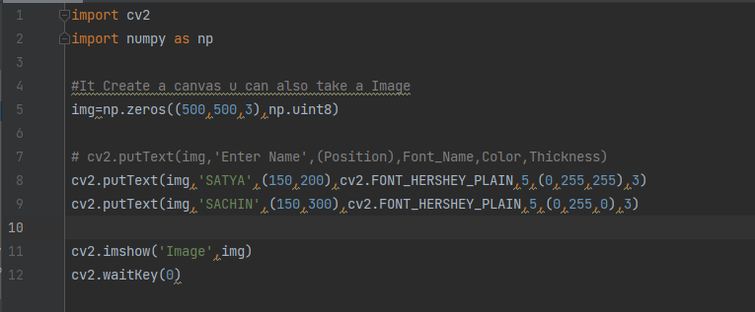

**O/P**

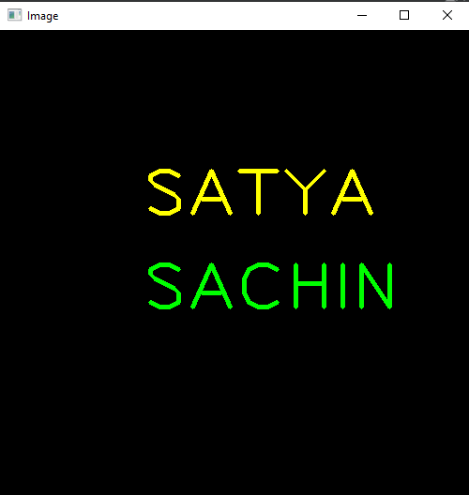

**Find and Draw Contours using OpenCV Python**

Contours are defined as the line joining all the points along the boundary of an image that are having the same intensity. Contours come handy in shape analysis, finding the size of the object of interest, and object detection.

OpenCV has findContour() function that helps in extracting the contours from the image. It works best on binary images, so we should first apply thresholding techniques, Sobel edges, etc.

Below is the code for finding contours –

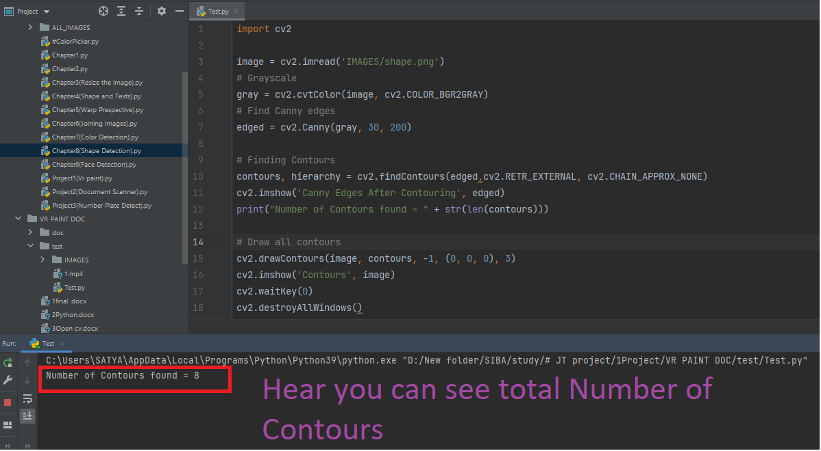

**O/P**

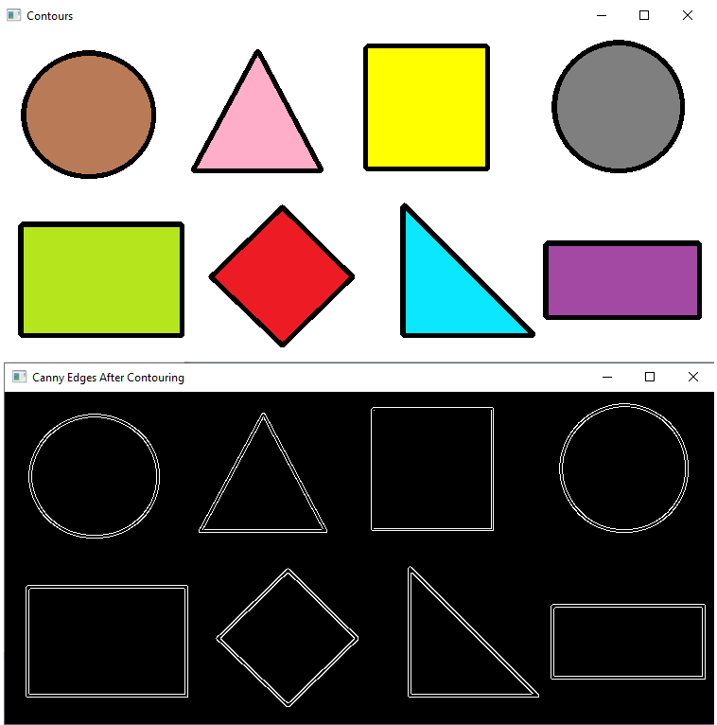

**CHAPTER-8**

**MediaPipe Hands: On-device Real-time Hand Tracking**

**Introduction**

Hand tracking is a vital component to provide a natural way for interaction and communication in AR/VR, and has been an active research topic in the industry [2] [15]. Vision-based hand pose estimation has been studied for many years. A large portion of previous work requires specialized hardware, e.g., depth sensors [13][16][17][3][4]. Other solutions are not lightweight enough to run real-time on commodity mobile devices [5] and thus are limited to platforms equipped with powerful processors. In this paper, we propose a novel solution that does not require any additional hardware and performs in real-time on mobile devices. Our main contributions are:

* An efficient two-stage hand tracking pipeline that can track multiple hands in real-time on mobile devices.
* A hand pose estimation model that is capable of predicting 2.5D hand pose with only RGB input.
* And open-source hand tracking pipeline as a ready-to go solution on a variety of platforms, including Android, iOS, Web (Tensorflow.js [7]) and desktop PCs.

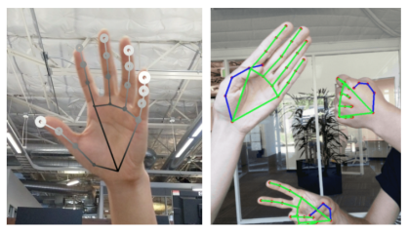

Figure 1:

Rendered hand tracking result. (Left): Hand landmarks with relative depth presented in different shades. The lighter and larger the circle, the closer the landmark is towards the camera. (Right): Real-time multi-hand tracking on Pixel 3.

**Overview**

The ability to perceive the shape and motion of hands can be a vital component in improving the user experience across a variety of technological domains and platforms. For example, it can form the basis for sign language understanding and hand gesture control, and can also enable the overlay of digital content and information on top of the physical world in augmented reality. While coming naturally to people, robust real-time hand perception is a decidedly challenging computer vision task, as hands often occlude themselves or each other (e.g., finger/palm occlusions and handshakes) and lack high contrast patterns.

MediaPipe Hands is a high-fidelity hand and finger tracking solution. It employs machine learning (ML) to infer 21 3D landmarks of a hand from just a single frame. Whereas current state-of-the-art approaches rely primarily on powerful desktop environments for inference, our method achieves real-time performance on a mobile phone, and even scales to multiple hands. We hope that providing this hand perception functionality to the wider research and development community will result in an emergence of creative use cases, stimulating new applications and new research avenues.



Tracked 3D hand landmarks are represented by dots in different shades, with the brighter ones denoting landmarks closer to the camera.

**ML Pipeline**

MediaPipe Hands utilizes an ML pipeline consisting of multiple models working together: A palm detection model that operates on the full image and returns an oriented hand bounding box. A hand landmark model that operates on the cropped image region defined by the palm detector and returns high-fidelity 3D hand keypoints. This strategy is similar to that employed in our MediaPipe Face Mesh solution, which uses a face detector together with a face landmark model.

Providing the accurately cropped hand image to the hand landmark model drastically reduces the need for data augmentation (e.g. rotations, translation and scale) and instead allows the network to dedicate most of its capacity towards coordinate prediction accuracy. In addition, in our pipeline the crops can also be generated based on the hand landmarks identified in the previous frame, and only when the landmark model could no longer identify hand presence is palm detection invoked to relocalize the hand.

The pipeline is implemented as a MediaPipe graph that uses a hand landmark tracking subgraph from the hand landmark module, and renders using a dedicated hand renderer subgraph. The hand landmark tracking subgraph internally uses a hand landmark subgraph from the same module and a palm detection subgraph from the palm detection module.

Note: To visualize a graph, copy the graph and paste it into MediaPipe Visualizer. For more information on how to visualize its associated subgraphs, please see visualizer documentation.

**Models**

**Palm Detection Model**

To detect initial hand locations, we designed a single-shot detector model optimized for mobile real-time uses in a manner similar to the face detection model in MediaPipe Face Mesh. Detecting hands is a decidedly complex task: our model has to work across a variety of hand sizes with a large-scale span (~20x) relative to the image frame and be able to detect occluded and self-occluded hands. Whereas faces have high contrast patterns, e.g., in the eye and mouth region, the lack of such features in hands makes it comparatively difficult to detect them reliably from their visual features alone. Instead, providing additional context, like arm, body, or person features, aids accurate hand localization.

Our method addresses the above challenges using different strategies. First, we train a palm detector instead of a hand detector, since estimating bounding boxes of rigid objects like palms and fists is significantly simpler than detecting hands with articulated fingers. In addition, as palms are smaller objects, the non-maximum suppression algorithm works well even for two-hand self-occlusion cases, like handshakes. Moreover, palms can be modelled using square bounding boxes (anchors in ML terminology) ignoring other aspect ratios, and therefore reducing the number of anchors by a factor of 3-5. Second, an encoder-decoder feature extractor is used for bigger scene context awareness even for small objects (similar to the RetinaNet approach). Lastly, we minimize the focal loss during training to support a large amount of anchors resulting from the high scale variance.

With the above techniques, we achieve an average precision of 95.7% in palm detection. Using a regular cross entropy loss and no decoder gives a baseline of just 86.22%.

**Hand Landmark Model**

After the palm detection over the whole image our subsequent hand landmark model performs precise key point localization of 21 3D hand-knuckle coordinates inside the detected hand regions via regression, that is direct coordinate prediction. The model learns a consistent internal hand pose representation and is robust even to partially visible hands and self-occlusions.

To obtain ground truth data, we have manually annotated ~30K real-world images with 21 3D coordinates, as shown below (we take Z-value from image depth map, if it exists per corresponding coordinate). To better cover the possible hand poses and provide additional supervision on the nature of hand geometry, we also render a high-quality synthetic hand model over various backgrounds and map it to the corresponding 3D coordinates.

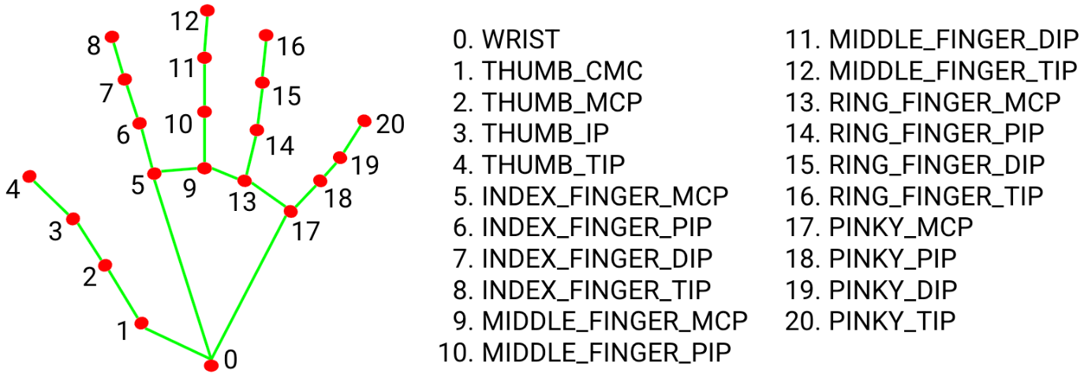

**Hand landmarks**

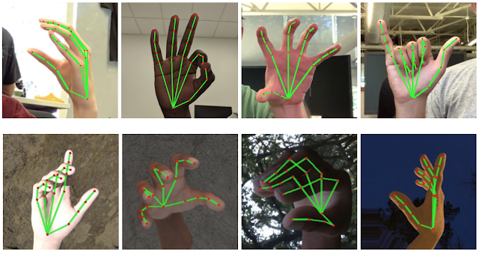

Top: Aligned hand crops passed to the tracking network with ground truth annotation. Bottom: Rendered synthetic hand images with ground truth annotation.

**Architecture**

Our hand tracking solution utilizes an ML pipeline consisting of two models working together:

* A palm detector that operates on a full input image and locates palms via an oriented hand bounding box.
* A hand landmark model that operates on the cropped hand bounding box provided by the palm detector and returns high-fidelity 2.5D landmarks.

Providing the accurately cropped palm image to the hand landmark model drastically reduces the need for data augmentation (e.g., rotations, translation and scale) and allows the network to dedicate most of its capacity towards landmark localization accuracy. In a real-time tracking scenario, we derive a bounding box from the landmark prediction of the previous frame as input for the current frame, thus avoiding applying the detector on every frame. Instead, the detector is only applied on the first frame or when the hand prediction indicates that the hand is lost.

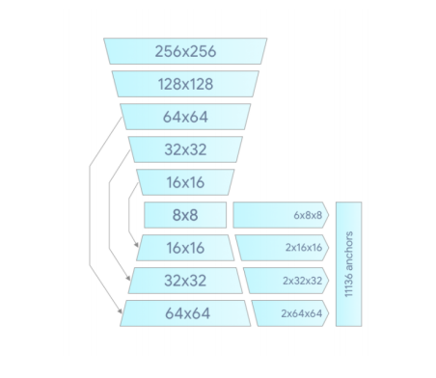

Figure 2: Palm detector model architecture.

**Blaze Palm Detector**

To detect initial hand locations, we employ a single shot detector model optimized for mobile real-time application similar to BlazeFace[1], which is also available in MediaPipe[12]. Detecting hands is a decidedly complex task: our model has to work across a variety of hand sizes with a large-scale span (∼20x) and be able to detect occluded and self-occluded hands. Whereas faces have high contrast patterns, e.g., around the eye and mouth region, the lack of such features in hands makes it comparatively difficult to detect them reliably from their visual features alone.

Our solution addresses the above challenges using different strategies.

First, we train a palm detector instead of a hand detector, since estimating bounding boxes of rigid objects like palms and fists is significantly simpler than detecting hands with articulated fingers. In addition, as palms are smaller objects, the non-maximum suppression algorithm works well even for the two-hand self-occlusion cases, like handshakes. Moreover, palms can be modelled using only square bounding boxes [11], ignoring other aspect ratios, and therefore reducing the number of anchors by a factor of 3∼5.

Second, we use an encoder-decoder feature extractor similar to FPN[9] for a larger scene-context awareness even for small objects.

Lastly, we minimize the focal loss[10] during training to support a large amount of anchors resulting from the high scale variance. High-level palm detector architecture is shown in Figure 2. We present an ablation study of our design elements in Table 1.

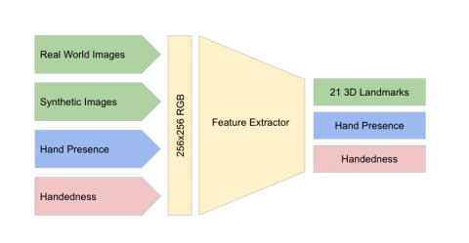

Figure 3: Architecture of our hand landmark model. The model has three outputs sharing a feature extractor. Each head is trained by correspondent datasets marked in the same color. See Section 2.2 for more detail.

**Hand Landmark Model**

After running palm detection over the whole image, our subsequent hand landmark model performs precise landmark localization of 21 2.5D coordinates inside the detected hand regions via regression. The model learns a consistent internal hand pose representation and is robust even to partially visible hands and self-occlusions. The model has three outputs (see Figure 3):

1. 21 hand landmarks consisting of x, y, and relative depth.
2. A hand flag indicating the probability of hand presence in the input image.
3. A binary classification of handedness, e.g., left or right hand.

We use the same topology as [14] for the 21 landmarks. The 2D coordinates are learned from both real-world images as well as synthetic datasets as discussed below, with the relative depth w.r.t. the wrist point being learned only from synthetic images. To recover from tracking failure, we developed another output of the model similar to [8] for producing the probability of the event that a reasonably aligned hand is indeed present in the provided crop. If the score is lower than a threshold then the detector is triggered to reset tracking. Handedness is another important attribute for effective interaction using hands in AR/VR. This is especially useful for some applications where each hand is associated with a unique functionality. Thus, we developed a binary classification head to predict whether the input hand is the left or right hand. Our setup targets real-time mobile GPU inference, but we have also designed lighter and heavier versions of the model to address CPU inference on the mobile devices lacking proper GPU support and higher accuracy requirements of accuracy to run on desktop, respectively.

**Dataset and Annotation**

To obtain ground truth data, we created the following datasets addressing different aspects of the problem:

* In-the-wild dataset: This dataset contains 6K images of large variety, e.g. geographical diversity, various lighting conditions and hand appearance. The limitation of this dataset is that it doesn’t contain complex articulation of hands.
* In-house collected gesture dataset: This dataset contains 10K images that cover various angles of all physically possible hand gestures. The limitation of this dataset is that it’s collected from only 30 people with limited variation in background. The in-the-wild and in-house dataset are great complements to each other to improve robustness.
* Synthetic dataset: To even better cover the possible hand poses and provide additional supervision for depth, we render a high-quality synthetic hand model over various backgrounds and map it to the corresponding 3D coordinates. We use a commercial 3D hand model that is rigged with 24 bones and includes 36 blendshapes, which control fingers and palm thickness. The model also provides 5 textures with different skin tones. We created video sequences of transformation between hand poses and sampled 100K images from the videos. We rendered each pose with a random high-dynamic-range lighting environment and three different cameras. See Figure 4 for examples.

For the palm detector, we only use in-the-wild dataset, which is sufficient for localizing hands and offers the highest variety in appearance. However, all datasets are used for training the hand landmark model. We annotate the realworld images with 21 landmarks and use projected groundtruth 3D joints for synthetic images. For hand presence, we select a subset of real-world images as positive examples and sample on the region excluding annotated hand regions as negative examples. For handedness, we annotate a subset of real-world images with handedness to provide such data.

**Results**

For the hand landmark model, our experiments show that the combination of real-world and synthetic datasets provides the best results. See Table 2 for details. We evaluate only on real-world images. Beyond the quality improvement, training with a large synthetic dataset leads to less jitter visually across frames. This observation leads us to believe that our real-world dataset can be enlarged for better generalization.

Our target is to achieve real-time performance on mobile devices. We experimented with different model sizes and found that the “Full” model (see Table 3) provides a good trade-off between quality and speed. Increasing model capacity further introduces only minor improvements in quality but decreases significantly in speed (see Table 3 for details). We use the TensorFlow Lite GPU backend for on device inference [6].

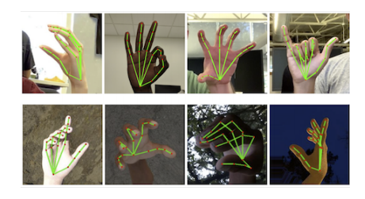

Figure 4: Examples of our datasets. (Top): Annotated realworld images. (Bottom): Rendered synthetic hand images with ground truth annotation. See Section 3 for details.

Model Variation Average Precision

No decoder + cross entropy loss 86.22%

Decoder + cross entropy loss 94.07%

Decoder + focal loss 95.7%

Table 1: Ablation study of palm detector design elements of palm detector.

Dataset MSE normalized by palm size

Only real-world 16.1%

Only synthetic 25.7%

Combined 13.4%

**Table 2: Results of our model trained from different datasets.**

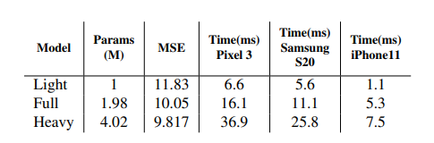

**Table 3: Hand landmark model performance characteristics.**

**Implementation in MediaPipe**

With MediaPipe[12], our hand tracking pipeline can be built as a directed graph of modular components, called Calculators. Mediapipe comes with an extensible set of Calculators to solve tasks like model inference, media processing, and data transformations across a wide variety of devices and platforms. Individual Calculators like cropping, rendering and neural network computations are further optimized to utilize GPU acceleration. For example, we employ TFLite GPU inference on most modern phones.

Our MediaPipe graph for hand tracking is shown in Figure 5. The graph consists of two subgraphs one for hand detection and another for landmarks computation. One key optimization MediaPipe provides is that the palm detector only runs as needed (fairly infrequently), saving significant computation. We achieve this by deriving the hand location in the current video frames from the computed hand landmarks in the previous frame, eliminating the need to apply the palm detector on every frame. For robustness, the hand tracker model also outputs an additional scalar capturing the confidence that a hand is present and reasonably aligned in the input crop. Only when the confidence falls below a certain threshold is the hand detection model reapplied to the next frame.

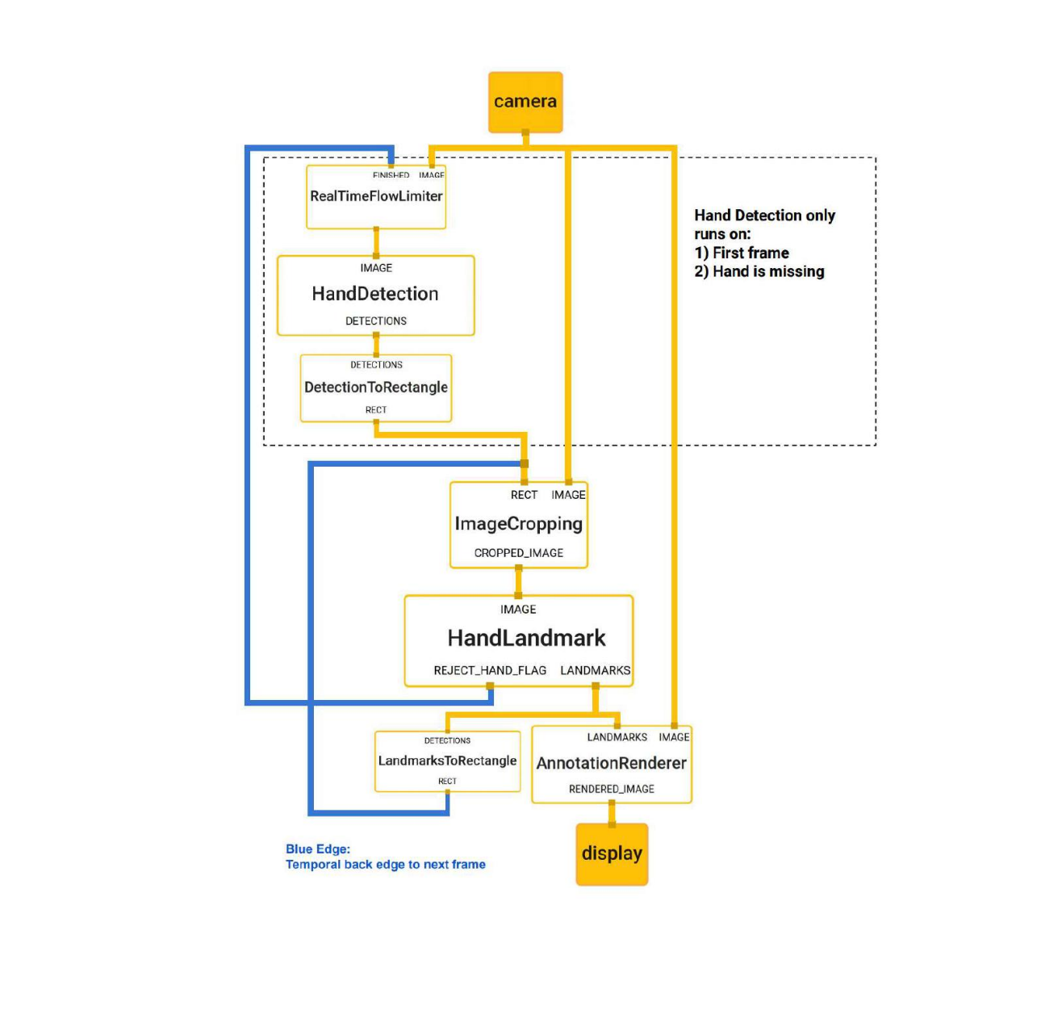Figure 5: The hand landmark models output controls when the hand detection model is triggered. This behaviour is achieved by MediaPipes powerful synchronization building blocks, resulting in high performance and optimal throughput of the ML pipeline.

**Application examples**

Our hand tracking solution can readily be used in many applications such as gesture recognition and AR effects. On top of the predicted hand skeleton, we employ a simple algorithm to compute gestures, see Figure 6. First, the state of each finger, e.g. bent or straight, is determined via the accumulated angles of joints. Then, we map the set of finger states to a set of predefined gestures. This straightforward, yet effective technique allows us to estimate basic static gestures with reasonable quality. Beyond static gesture recognition, it is also possible to use a sequence of landmarks to predict dynamic gestures. Another application is to apply AR effects on top of the skeleton. Hand based AR effects currently enjoy high popularity. In Figure 7, we show an example AR rendering of the hand skeleton in neon light style.

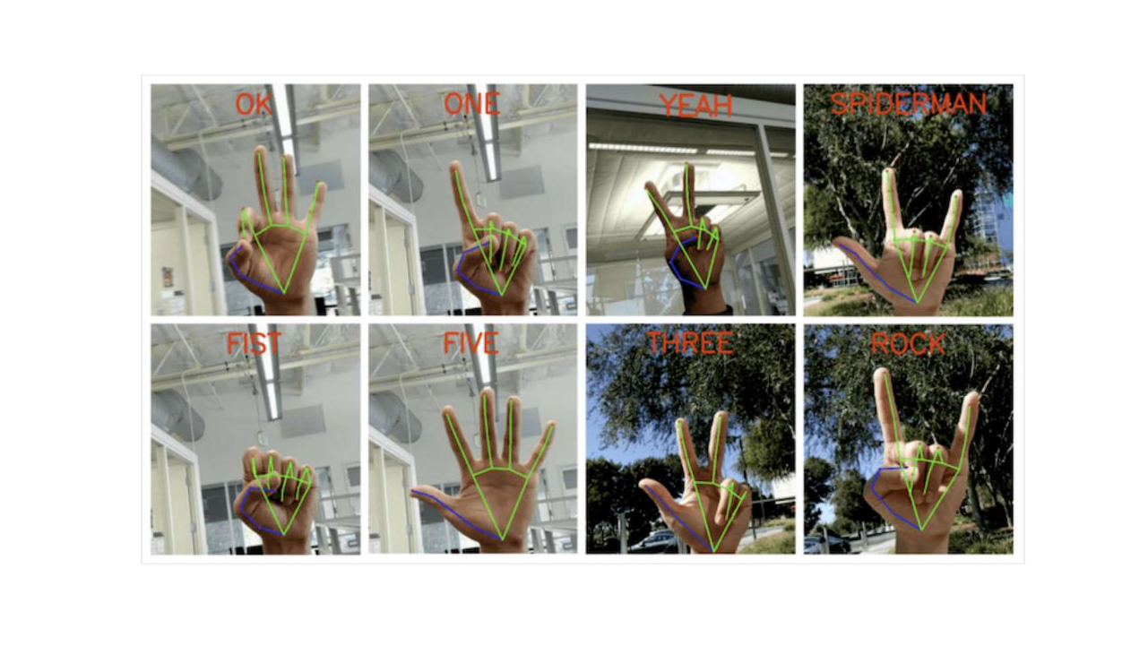

Figure 6: Screenshots of real-time gesture recognition. Semantics of gestures are rendered at top of the images.

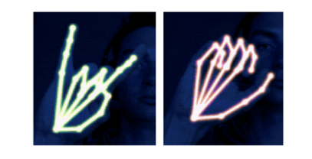

Figure 7: Example of real-time AR effects based on our predicted hand

In this paper, we proposed MediaPipe Hands, an end-toend hand tracking solution that achieves real-time performance on multiple platforms. Our pipeline predicts 2.5D landmarks without any specialized hardware and thus, can be easily deployed to commodity devices. We open sourced the pipeline to encourage researchers and engineers to build gesture control and creative AR/VR applications with our pipeline.

**CHAPTER-9**

In the upper Chapter we discuss all the topic and all the requirements Which is we use in our project.

First, we Track our hand Through which we draw on screen

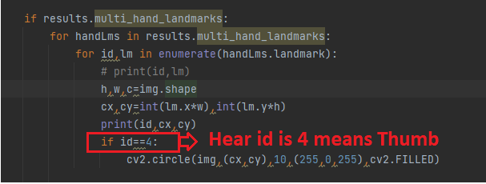

**Here is the for-thumb detection**



Hear you can see clearly in Thumb a pink mark is appear, Because I place the mark on the thumb you can place anywhere in your hand.



**All Finger Points**

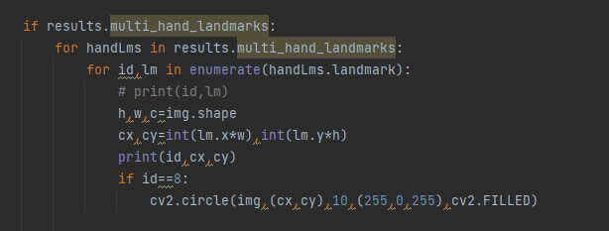

**Here is the for-index finger detection**





**All Point**

In this Picture we can see clearly that all the point are detracted properly.

Hear we create a finger counter to explain how this module work properly and accurately.



**Finger counter**

**The Project Demonstration**

Hear you can see the of the actual output of the Program



Index finger =>> To write

Two fingers =>> To Move Around

In upper there are 4 color and one eraser when you select something by two finger it selects and when you use two finger it moves the point and ready to draw a new point.

Here you can see when I use my single finger it draws in the screen and when I use my two fingers It selects the above color and the eraser.

My camera specs are low that's why you can fill some lag and my lighting condition, not that must good so it looks some laggy but when you use a good camera and good lighting condition it works smoothly and properly.

We can also improve this project and modified to make some 3D model like car and may more so we can explain some one in detail we see in some movies.

**CHAPTER-10**

**CONCLUSION**

The Virtual Painter Using Computer Vision is a very effective tool which can be used to a great extent. The System is portable and can be easily access and used on any computer. Using this software, proxies are completely avoided with a pure software approach. It will reduce the time, effort and resources such as paper for both the parties involved in the process. Moreover, it is specially use for Quick explanation in online classes and meeting.